**JAVASCRIPT**

JavaScript is a **high-level, interpreted programming language** used to create **interactive and dynamic web pages**. It is one of the core technologies of web development, alongside **HTML** and **CSS**. It is commonly used for **developing** both **web and mobile applications.**

A **high-level programming language** is a **human-understandable language**. **Low level language** like assembly language are closer to the **machine code** and computers hardware and require more knowledge to work with.

JS is a **loosely type language**. Loosely type means it does not attaches any data type to its variable. So if I create a variable x and put number I it, later on I can change it to string.

JavaScript is mainly used to:

* **Make web pages interactive** (e.g., pop-ups, sliders, accordions).
* **Handle user events** (e.g., button clicks, form submissions).
* **Manipulate the DOM** (change the content and style of a webpage dynamically).
* **Fetch data from servers** using APIs (e.g., fetch() or AJAX).
* **Create animations and effects**.
* **Develop modern web apps** (e.g., React.js, Vue.js, and Angular use JavaScript).

In chrome you can directly write javascript using console.  **inspect --> console**

alert("Hello World") -- will display like alert

console.log("Hello Word") -- o/p will display in console window

You can do many things like calculation, add, sub, etc..

Even you are offline you can perform calculations. How is it possible? JS runs on client side browser.

In browser js runs in the client side. Client means the person who is using the internet. That means the computation is not done on the server, it is being done in your house, your computer (this is known as client side javascript) (You can also say that JS is used for client side scripting)

**Difference between JS and other programming languages**

* **Purpose and usage**

**JavaScript**: Originally designed for web browsers to make websites interactive (client-side scripting). Now also used on servers via **Node.js**.

**Others (like Python, Java, C++)**: Usually general-purpose languages used for everything from desktop apps to servers, data science, games, etc.

* Typing System

**JavaScript**: **Dynamically typed** – you don’t declare variable types.

**Others: Java/C++**: **Statically typed** – variable types must be declared. **Python**: Also dynamically typed like JS, but more structured.

* **Execution Environment**

**JavaScript**: Runs in the browser (Chrome, Firefox, etc.) and on servers with **Node.js**.

**Others**: **Python** runs in its own interpreter. **Java** runs on the Java Virtual Machine (JVM). **C++** is compiled into machine code.

**To create websites which all basic technologies required?** HTML, CSS, JS

Without html possible? NO, very imp!! Because HTML contains CSS and JS. HTML is a must for developing any website.

Without CSS? Yes, but the website will look ugly. We need CSS to design like borders, background, font style, etc.

Without JS? Yes, but the user won't be able to interact with the elements. It won't be interactive. What does it mean? Suppose you have a button, and you want some reaction when button is clicked, but maybe that won't happened because you're not using JS.

Comparing to real life example, HTML is like a skeleton, CSS is the skin, nose, hairs, everything that makes you look beautiful and JS is our memory, brain, (which handles overall functions of the body) that thinks and make use both of the things and helps in working.

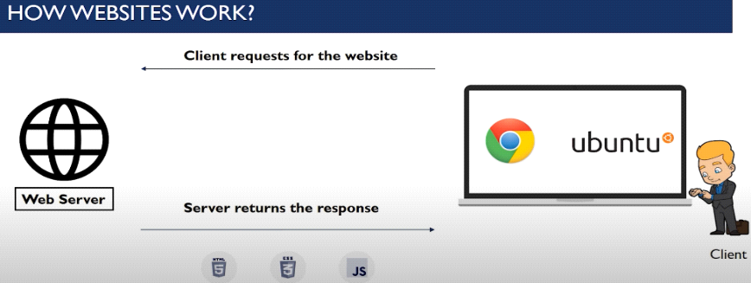

JS? JS is used in frontend as well as backend.

With the help of nodeJS, JS can be used in backend. NodeJs is a web server.

If you want to run inside the browser, you can run using JS, but if you want to run outside the browser, you need nodeJS.

**JavaScript in <head> or <body>**

You can place any number of scripts in an HTML document.

Scripts can be placed in the <body>, or in the <head> section of an HTML page, or in both.

**Placing JavaScript in the <head>**

Pros:

1. The script loads before the page content.
2. Useful for scripts that don’t depend on HTML elements (e.g., analytics, tracking codes).

Cons:

1. JavaScript executes before the page loads, which can block rendering and slow down page speed.
2. If the script manipulates elements that aren’t yet loaded, it may cause errors.

**Placing JavaScript in the <body> (Before </body>)**

Pros:

1. The HTML content loads first, ensuring a faster user experience.
2. JavaScript executes after the DOM is fully available, preventing errors.
3. Recommended for DOM manipulation scripts.

Cons:

1. If a script is required early (like Google Analytics), placing it in the body might delay execution.

**JavaScript Output**

JavaScript can "display" data in different ways:

* Writing into an HTML element, using innerHTML.

Changing the innerHTML property of an HTML element is a common way to display data in HTML.

* Writing into the HTML output using document.write().

Never call document.write after the document has finished loading. It will overwrite the whole document.

The **document.write()** method should only be used for testing.

* Writing into an alert box, using **window.alert()**. (It is like a mini alert pop up window)

You can skip the window keyword.

In JavaScript, the window object is the global scope object. This means that variables, properties, and methods by default belong to the window object. This also means that specifying the window keyword is optional.

* Writing into the browser console, using console.log().

For debugging purposes, you can call the console.log() method in the browser to display data.

* prompt – used to take users input as string

by default, type of any operator is string, so even if we provide any number as input, type of that number will be string. So, to convert Number.parseInt()

* **confirm** – shows a message and waits for the user to press ok or cancel. Returns true for ok and false for cancel.

confirm("Press a button!");

**JavaScript Print**

JavaScript does not have any print object or print methods. You cannot access output devices from JavaScript.

The only exception is that you can call the window.print() method in the browser to print the content of the current window. (Basically this will print the page. i.e. option will come to print)

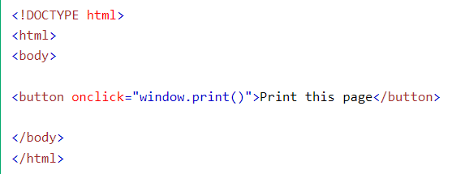

**Console Object Methods**

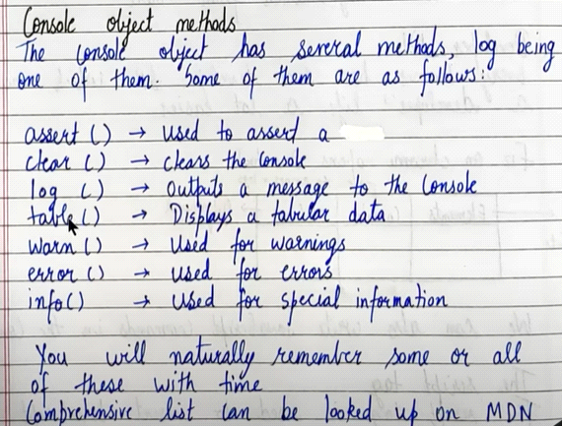

* console.assert(); static method writes an error message to the console if the assertion is false. If the assertion is true, nothing happens.

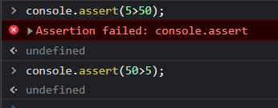

* console.error();

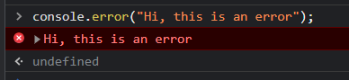

* console.clear(); -- it will clear the console.

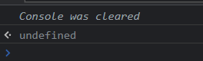

* console.table(); - show data in tabular format.

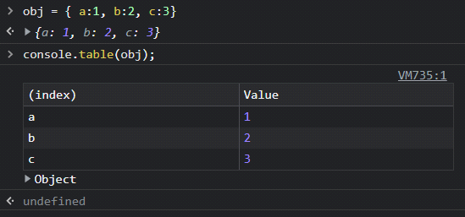

* console.warn();

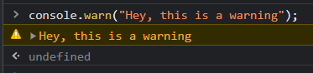

* console.time(); - console.timeEnd(); - will display how much time the process took.

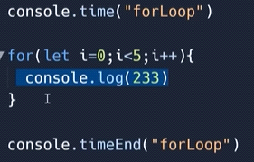

**Difference between console.log and console.dir**

console.dir - it will print it considering it as an object and along with that other properties.

console.log - shows the element DOM tree.

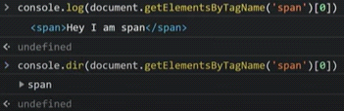

**JavaScript Keywords**

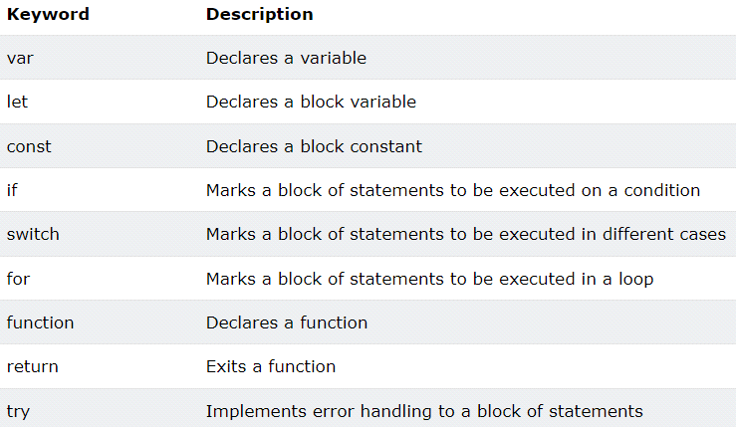

**JS Naming Conventions**

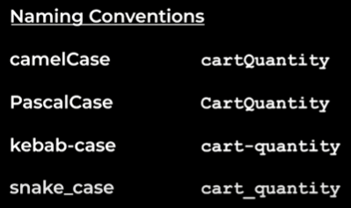

1. **camelCase:**

JavaScript programmers tend to use camel case that starts with a lowercase letter.

Ex: masterCard, interCity

1. **PascalCase (upper camelCase):**

Ex: FirstName, LastName

1. **kebab-case(Hyphens):**

Hyphens are not allowed in JavaScript (used in HTML, CSS). They are reserved for subtractions.

Ex: first-name, last-name.

1. **snake_case(Underscore):**

first_name, last_name, master_card, inter_city.

**JavaScript Programs, Statements and Semicolon**

A **computer program** is a list of "instructions" to be "executed" by a computer.

In a programming language, these programming instructions are called **statements**.

A **JavaScript program** is a list of programming **statements**.

JavaScript statements are composed of:

Values, Operators, Expressions, Keywords, and Comments.

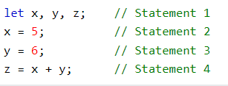

Semicolons separate JavaScript statements.

When separated by semicolons, multiple statements on one line are allowed

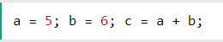

String and number is printed in diff color (black and blue)

**JavaScript variables**

Variables? Variables are containers for storing data (storing data values).

4 Ways to Declare a JavaScript Variable:

Using **var**, using **let**, using **const**, using nothing

An equal sign is used to assign values to variables.

In this example, x is defined as a variable. Then, x is assigned (given) the value 6:

let x; x = 6;

**JavaScript var**

var is used to declare variables in JavaScript (before ES6). It is **function-scoped,** meaning it is accessible within the function in which it's defined, can be **re-declared and reassigned**, and is hoisted (moved to the top of its scope with a special value of **undefined**).

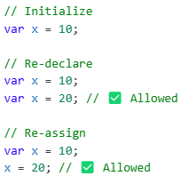

**JavaScript let**

let is a **block-scoped** variable introduced in **ES6**. It **cannot be re-declared in the same scope but can be reassigned**. It is hoisted, but in a **Temporal Dead Zone (TDZ)** — you can’t access it before the line where it’s declared.

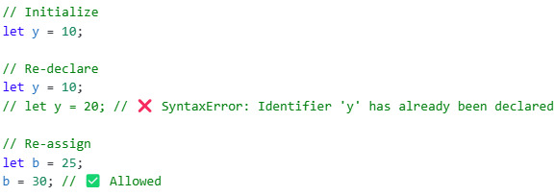

let z = 13;

if(true){

let z = "Fun"; //works without any error as scope is different.

console.log(z) //prints "Fun"

}

console.log(z) //prints 13

**JavaScript Const**

const is also **block-scoped and introduced in ES6**. It must be **initialized at the time of declaration** and **cannot be** **reassigned or re-declared**. However, if it's used with an object or array, the content can still be changed (mutated).

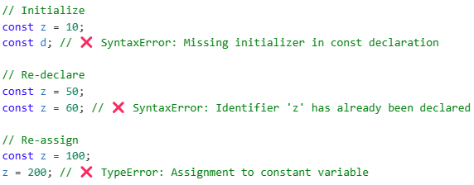

When to use JavaScript const? **Always declare a variable with const when you know that the value should not be changed.**

Use const when you declare:

* A new Array
* A new Object
* A new Function
* A new RegExp

The keyword const is a little misleading. It does not define a constant value. It defines a constant reference to a value.

Because of this you can NOT:

* Reassign a constant value
* Reassign a constant array
* Reassign a constant object

But you CAN:

* Change the elements of constant array
* Change the properties of constant object

**Few more Exs -**

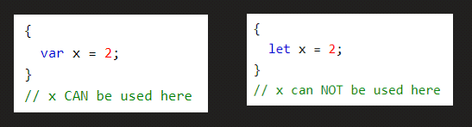

Redeclaring Variables

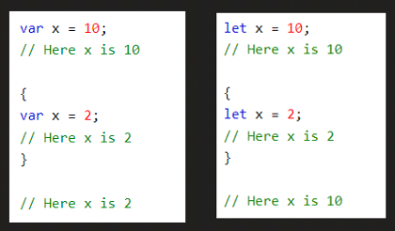

Redeclaring a var with let, in same block, not allowed, but in another block is allowed.

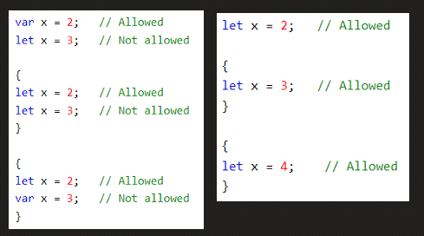 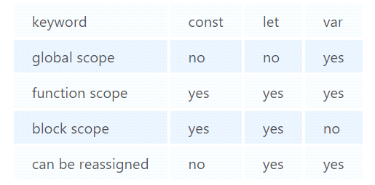

**Block and Block Scope**

**Block** (compound statements) - it is defined by curly braces {}. It is used to combine multiple JS statement into one statement so that we can use it at those places where javascript expects to have single statement.

Scope- scope of a variable or a function is the place where these are accessible.

**Block scope** - block values are stored inside separate memory than global.

let & const are hoisted in a block scope. var is in global scope

let and const variables are stored in block space, so it is called block-scoped but var variables can be accessed outside the block as it is stored in the Global object memory space, hence it is called Global scoped.

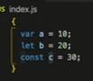 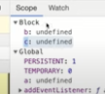

Once the block of JS code is executed, let and const are now no longer accessible. As it is in block scope.

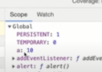

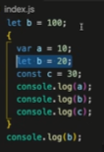 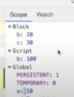

**Shadowing in JS**

**Shadowing** happens when a **variable in a local scope** (like inside a function or block) has the **same name** as a variable in an outer scope. The inner (local) variable **"shadows" or hides** the outer one, meaning the outer one becomes **inaccessible** in that scope.

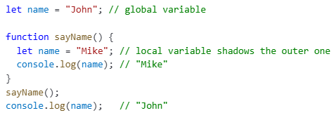

**Hoisting**

Hoisting is a mechanism where variables and function declarations are moved to the top of their scope before code execution. This means you can use variables and functions before declaring them without getting errors.

This happens due to Memory allocation in execution context.

Before code get executed, memory allocation stat for all var & fun due to that we can access them before declaration.

Hoisting applies to variable declarations made using var , let , const , and function declarations.

* For var: The variable is hoisted but initialized as undefined.
* For let and const: The variables are hoisted but are in a Temporal Dead Zone (TDZ), meaning they cannot be accessed before the actual declaration.
* For functions: The entire function definition is hoisted, making the function usable before its declaration.

Most of other programming language it throws an error it is not possible to access variable fun before declaration.

**Global Scope**

Here, we try to access x it will give not defined error because Hoisting happens only for those variable who declared by var, let, const.

For b, it is declared inside function due to block scope not possible to access b outside the function.

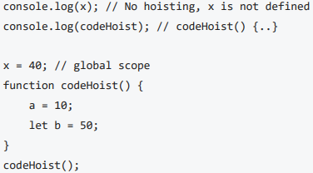

**Hoisting with var**

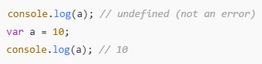 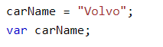

**Hoisting with let and const**

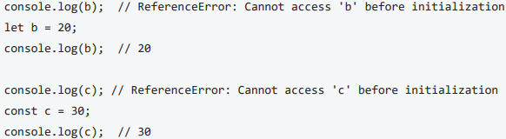

Variables declared with let and const are hoisted but are placed in a Temporal Dead Zone (TDZ).

The TDZ is the phase from the start of the block until the variable is declared and initialized.

During this period, accessing the variable will throw a **ReferenceError**. The variable is only available after the declaration.

let and const are hoisted but its memory is allocated at other place than window which cannot be accessed before initialisation. **Temporal Dead Zone exists until variable is declared and assigned a value.**

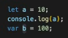 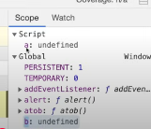

**Hoisting with function**

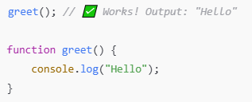

**Function Expressions**

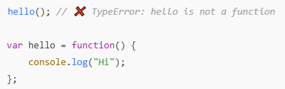

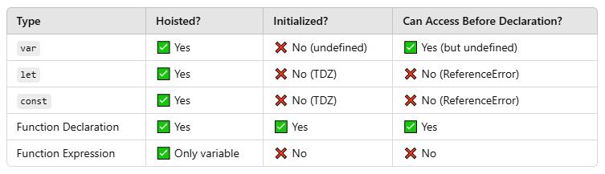

**JavaScript Error**

**There are three types of error**:

[1] **referenceError** {while trying to access variable which is not there in global memory}



[2] **typeError**: A **TypeError** happens when you try to use a **value in the wrong way**, like:

Using a method that doesn't exist on that data type. Doing something with a variable that its type doesn't support.

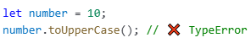

number is a **number** (10).

.toUpperCase() is a **method** that only works on **strings**, like "hello".toUpperCase().

JS be like: "Hey! You're trying to use a string method on a number. That's a **TypeError**."

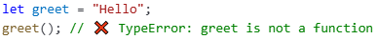

greet is a **string** ("Hello").

But we're using greet() with **parentheses**, like it's a **function**.

JS be like: “Wait! You're trying to **call a string like a function**. That’s a TypeError.”

[3] **syntaxError** {when proper syntax(way of writing a statement) is not used}.



**JavaScript Data Types**

Primitive data types can store **only a single value**. To store **multiple and complex values**, non-primitive data types are used. **Primitive data types are immutable** while **non-primitive data types are mutable**.

1. **Primitive Types (Shortcut to remember – NNBBSSU)**

N - Null

N - Number

B - Boolean

B - BigInt

S - String

S - Symbol

U - Undefined

* Null - It represents a non-existent or an invalid value. It is commonly used when you have declared a variable but either you do not want to assign it to a value yet or it should not have a value at all.

**var** z = null;

* Number - It represents both integer and floating-point numbers. It also includes special values like infinity, -infinity, and NAN.

**var** x = 3; //without decimal **var** y = 3.6; //with decimal **let price =** infinity;

* Boolean - It represents a logical entity and can have only two values: true or false. Booleans are generally used for conditional testing.

**var** a = 2; **var** b = 3; **var** c = 2; **let** isAvailable = true;

(a == b) // returns false (a == c) //returns true

* BigInt - This data type is used to store numbers which are above the limitation of the Number data type. It can store large integers and is represented by adding “n” to an integer literal.

**var** bigInteger = 234567890123456789012345678901234567890n;

* String - It represents a sequence (series) of characters, or a text. Strings can be created using a single quotation mark (‘…’), double quote (“…”), or backticks (`…`).

**var** str = "Vivek Singh Bisht"; //using double quotes **var** str2 = 'John Doe'; //using single quotes

**var** str3 = `Hi, ${str1}`; // using backtick

* Symbol - It is a new data type introduced in the ES6 version of JavaScript. It is used to store an anonymous and unique value. It represents a unique and immutable identifier which is often used for object properties to avoid naming conflicts.

**var** symbol1 = Symbol('symbolA'); **var** symbol2 = Symbol('symbolA');

**console.log(symbol1 === symbol2);**

* Undefined - When a variable is declared but not assigned, it has the value of undefined and it’s type is also undefined. (it is a default value)

**var** x; // value of x is undefined **var** y = undefined; // we can also set the value of a variable as undefined

To know the type of a JavaScript variable, we can use the **typeof**operator.

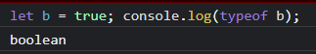

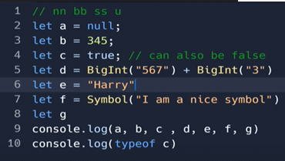 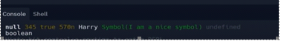

1. **Non-primitive -**

Object – Used to store collection of data. (Are like key-value pairs)

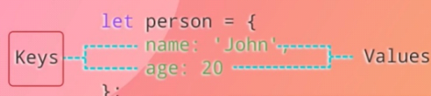 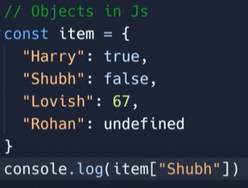 //**false**

Arrays are mutable, arrays can be changed. Strings are immutable, cannot be changed.

**Arrays**-

You can change the elements of a constant array

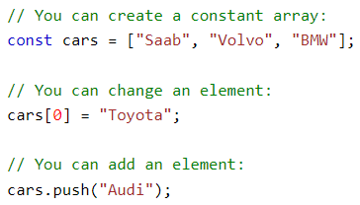

But you cannot reassign the arrays

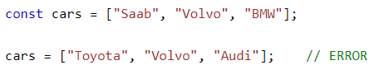

**Objects** -

You can change the properties of a constant object

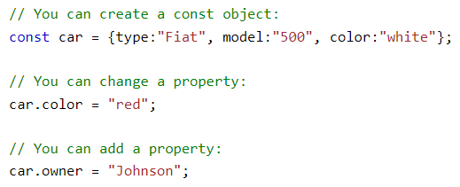

But you cannot reassign the object

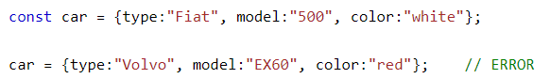

**Loose (Double) Equality (==) & Strict (Triple) Equality (===)**

**Loose Equality** (==) – Converts values to the same data type before comparing (type coercion).

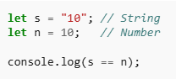 // true (shorter way – only checks value)

"10" (string) is converted to 10 (number).

The comparison becomes 10 == 10, which is true.

Type coercion allows values of different types to be considered equal.

**Strict Equality (===) –** Compares both value and data type, without converting types.

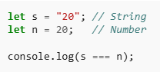 // false (shorter way – checks value and conversion (type))

"20" (string) is not converted to 20 (number).

Since they have different types, === returns false.

Strict equality does not allow type conversion, so only values with the same type are considered equal.

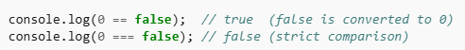

In JavaScript, non-primitive **(objects and arrays) are compared by reference**, not by value.



In JavaScript, **arrays are objects**. **Objects and arrays are compared by reference**, not by their content or structure.

Even if both arrays are empty ([] and []), they are **two different objects in memory**. Since **their references (memory addresses) are different**, == gives false

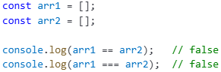

But if **both variables point to the same array**, then

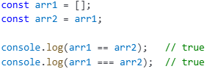

(Here, both arr1 and arr2 are **same reference**.)

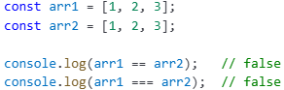

Even though values inside are same, arr1 and arr2 are **different objects in memory.**

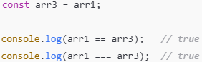

Now arr3 points to the same memory as arr1

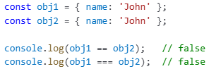

Even though they look identical, **they are different references in memory**.

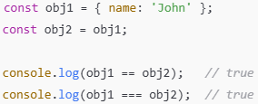

Here, obj2 points to the **same object** as obj1

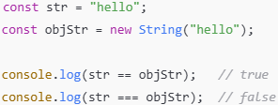

== does **type coercion**: objStr is an object, but gets converted to string "hello"

=== does **strict type check**: string !== object, so false

1. console.log([] == ![]); // true

**step1:** [] is a **truthy** value in JavaScript. ![] means **not truthy**, so it becomes false. ![] → false

**step2:** [] == false, So the original code becomes: console.log([] == false);

Now == does **type coercion** because types are different:

1. An array ([]) is converted to a primitive type (usually a string).

2. [] becomes '' (empty string)

**Step3:** Again type coercion: false becomes 0. '' becomes 0

**[] == ![] returns true** because ![] becomes false, and when comparing [] == false, JavaScript type converts the array [] into an empty string '', which is then converted to 0, and false also becomes 0. So 0 == 0 gives true

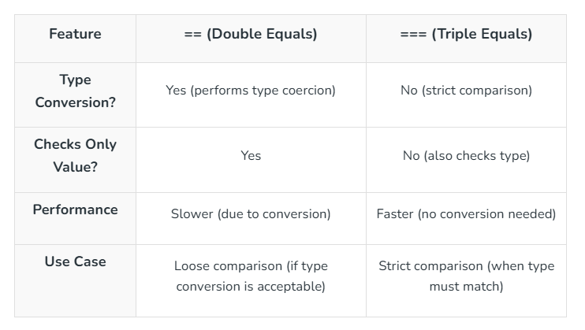

**Type Coercion**

**Type Coercion** is the automatic conversion of **one data type into another** by JavaScript when performing operations. It happens in both **implicit** (automatic) and **explicit** (manual) ways.

**1. Implicit Type Coercion** (Automatic Conversion)

JavaScript automatically converts one type to another when needed.

Example 1: String + Number → String

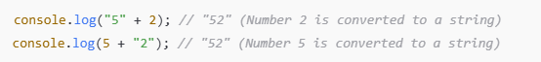

**Why?**  
When using the + operator, if one operand is a string, JavaScript **converts the other to a string** and performs **concatenation**.

Example 2: String - Number → Number

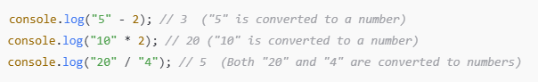

**Why?** Operators like -, *, / trigger **numeric conversion** if the operands are strings containing numbers.

console.log('25' - 10); // 15

console.log('25' + 10); // 2510

Example 3: Boolean to Number

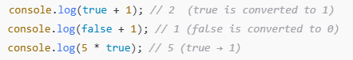

**Why**?

**true** is treated as 1, **false** is treated as **0**

Example 4: Null and Undefined

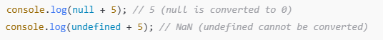

**Why**?

null converts to 0, undefined becomes NaN (Not a Number) when used in arithmetic operations.

If we try to convert a string into a no, will print NaN (not a number)

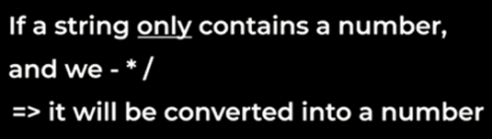

console.log({} + []); //0

Because {} at the start is treated as an empty block, and +[] converts the empty array into '' (empty string), and +'' becomes 0. So the output is 0.

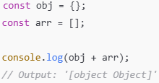

Note: In JavaScript, **if one side is a string, the + operator always does string concatenation** — **never math**!

**{} + 1 // '1'**

If {} is **at the start of a line**, it's treated like an **empty block**. Then +1 is evaluated.

**({}) + 1 // '[object Object]1'**

({}) → empty object → '[object Object]'

'[object Object]' + 1 → '[object Object]1' (string concatenation)

**null + 1 // 1**

null becomes 0 in numeric operations. 0+1 = 1

**undefined + 1 // NaN**

undefined becomes NaN (Not a Number) in numeric operations. Anything + NaN = NaN

**[] + 1 // '1'**

[] is converted to '' (empty string). '' + 1 = '1'

To explicitly convert?

Console.log(+a);

-'24' + 10 ? -14

null means empty value var a; //undefined

**Typeof null – object** //Why null is object? In js, everything is object.

**Typeof undefined – undefined**

**2. Explicit Type Coercion (Manual Conversion)**

You can manually convert types using JavaScript functions.

Example 1: String Conversion

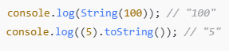

Example 2: Number Conversion

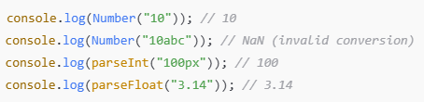

Example 3: Boolean Conversion

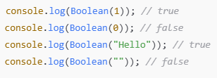

Truthy values → Non-empty strings, non-zero numbers, objects  
Falsy values → 0, "", null, undefined, NaN

**Truthy and Falsy Values**

Truthy Value – a truthy value is a value that is considered true when used in a [Boolean](https://developer.mozilla.org/en-US/docs/Glossary/Boolean) context. All values are truthy unless they are defined as [falsy](https://developer.mozilla.org/en-US/docs/Glossary/Falsy). (Behaves just like truth).

**Truthy Values -**

1. **Non-zero numbers**: 42, -1, 3.14
2. **Non-empty strings**: "hello", "0", " "
3. [Objects](https://www.geeksforgeeks.org/objects-in-javascript/)**and**[arrays](https://www.geeksforgeeks.org/javascript-arrays/): {}, []
4. [Functions](https://www.geeksforgeeks.org/functions-in-javascript/): function() {}
5. [Dates](https://www.geeksforgeeks.org/javascript-date/): new Date()
6. [Symbols](https://www.geeksforgeeks.org/javascript-symbol-method/): Symbol()
7. [BigInt values](https://www.geeksforgeeks.org/javascript-bigint/)other than 0n: 10n

**Falsy Values -**

1. False
2. 0, -0 and 0n (BigInt zero)
3. ‘’ ‘’, ‘’ (empty strings)
4. Null, undefined and NaN
5. Document.all

Some values always evaluate to false when converted to a Boolean.

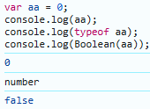 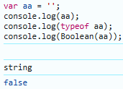

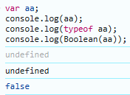 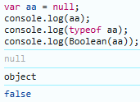 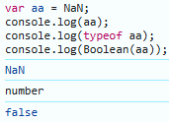

When you declare **var aa;** without assigning a value, JavaScript automatically sets its value to undefined.

You've explicitly assigned **null** to the variable. **typeof null** returns "**object**" due to a historical bug in the language.

**Comparison Operator** -

Instead of doing comparisons, we can use truthy and falsy values as shortcuts.

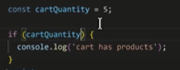 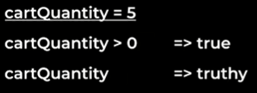 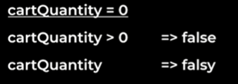

Logical Operator -

* && (AND): Returns the first falsy operand or the last operand if all are truthy.
* || (OR): Returns the first truthy operand or the last operand if all are falsy.

Example- Let’s say we have an online store that has recently introduced a loyalty points system. We store users as JSON objects, and only newly created users have the loyaltyPoints field.

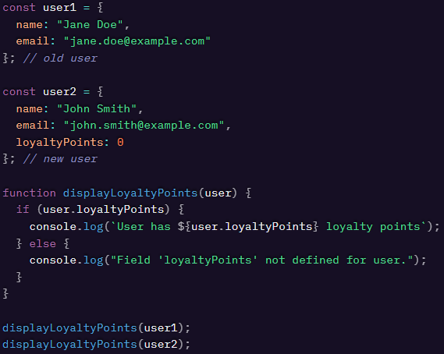

Based on a cursory reading of this code, we might expect the function displayLoyaltyPoints() to follow the else path for our first user and the if path for our second user. However, if we run this code, we’ll see that it follows the else path in both cases, even though loyaltyPoints is defined for the second user.

Because 0 is a falsy value, the if condition in our displayLoyaltyPoints() function will evaluate to false when provided with a user whose loyaltyPoints property is set to 0. if condition will also evaluate to false if the loyaltyPoints field does not exist (making it undefined).

**Logical Operator** –



Which means not falsy. i.e. truthy value

**NaN** – not a number

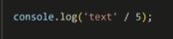

**Undefined** – something doesn’t have a value

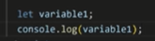

Consider the below example:

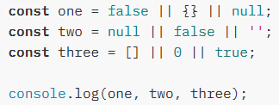 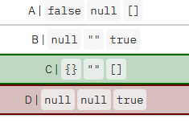

**With the || operator, we can return the first truthy operand. If all values are falsy, the last operand gets returned.**

(false || {} || null): the empty object {} is a truthy value. This is the first (and only) truthy value, which gets returned. one is equal to {}.

(null || false || ""): all operands are falsy values. This means that the last operand, "" gets returned. two is equal to "".

([] || 0 || ""): the empty array[] is a truthy value. This is the first truthy value, which gets returned. three is equal to [].

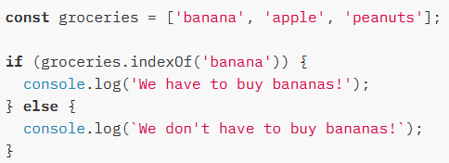 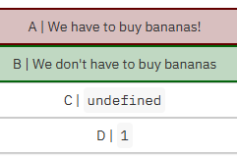

We passed the condition groceries.indexOf("banana") to the if-statement. groceries.indexOf("banana") returns 0, which is a falsy value. Since the condition in the if-statement is falsy, the code in the else block runs, and we don't have to buy bananas! gets logged.

**Alternate approach of if-else statements**

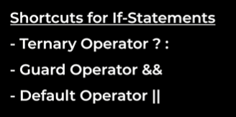 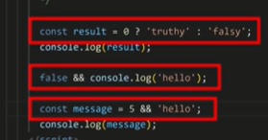

**Object in JavaScript**

**Object** is a collection of **key-value pairs**. It is used to store multiple pieces of related data in a structured way.

An object let us (group & use) multiple values together. Inside an object, we can store any type of value. It includes boolean, strings, numbers and other objects and also functions. **Objects themselves are also values.**

**Why objects?** Make our code more organized

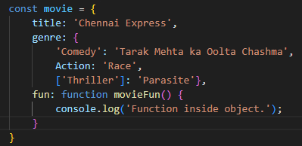

console.log(movie); // will display all the object

console.log(movie.genre.Comedy); // dot notation

movie.fun(); // will execute function

Two types of Notation:

1. **Dot Notation**: The Dot Notation approach involves using a dot or period (.) and a key to access a property.

Syntax: object.key

Example: **console.log(movie.genre);**

**console.log(movie.genre.Comedy);**

1. **Bracket Notation** (let us use properties that don’t work with dot notation): The Bracket Notation approach involves using square brackets, in which you have an expression that evaluates to a value. That value serves as a key for accessing the property.

Syntax: object[expression]

Example: **console.log(movie.genre['Comedy']);**

**console.log(movie["genre"]['Comedy']);**

**Which notation to use?** Use dot notation by default as it is shorter and easier to read. But if we want property that don’t use dot notation then use bracket notation.

**JSON**

**JavaScript object Notation** is a lightweight **data format** used to store and exchange data between systems (like servers and web applications).

It is basically a syntax, similar syntax to javascript notation but has less features.

JSON looks similar to JavaScript objects but follows strict rules:

1. Data is stored in **key-value pairs**.
2. Keys **must be in double quotes** ("name": "John", not name: "John").
3. Values can be **strings, numbers, booleans, arrays, objects, or null**.
4. No **trailing commas**.

**Why JSON?** JavaScript object only makes sense in JS. JSON syntax can be understood by almost every other programming languages. So, JSON syntax is more universal.

**We use json** -

1. when we send data between computers
2. when we store data.

**JS vs JSON**

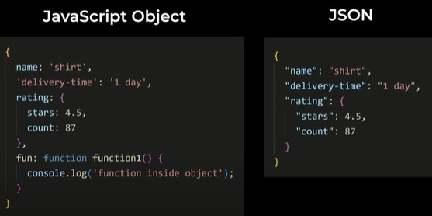

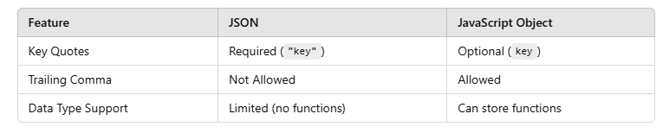

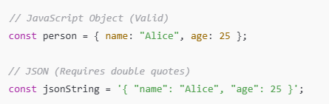

**Built-in JSON Object**

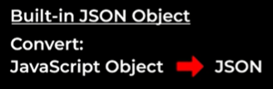

1. **json.stringify()** (converts javascript value to a json string) - stringify is a method of the json object. So it’s a function that is saved inside method. Inside bracket we add json object to convert json string.

**JSON.stringfy()** Example **-**



console.log(movie); // will display all the object

// **Converting JavaScript to JSON Object**

console.log(JSON.stringify(movie)); // function will not get displayed as json does not support function

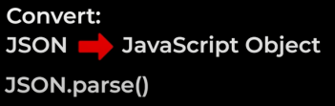

1. **JSON.parse()** – parses a JSON string to javascript object

// **Converting JSON to JavaScript**

console.log(JSON.parse(JSON.stringify(movie)));

**localStorage** – save values more permanently. So far we are saving in variables. Variables are termporary. If we refresh/close the page, all the variables are deleted (Eg – Rock, Paper, Scissor game project).

Localstorage doesn’t get deleted when we refresh the page. (supersimple.dev/projects/objects)

**Locastorage only support strings**

**localStorage vs sessionStorage vs Cookies**

All three methods store data in the browser, but they have key differences in lifetime, size, and accessibility.

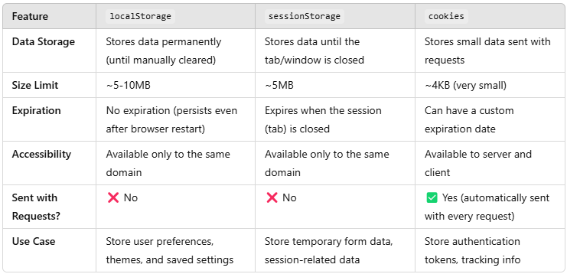

**localStorage** (Permanent Storage)

Stores data **without expiration.**

Data persists **even after browser refresh or reopening.**

Example: Storing & Retrieving Data



Removing Data



**Stores data permanently, up to 10MB, doesn't expire.**

**sessionStorage** (Temporary Storage)

Data exists **only while the tab is open** (If we refresh data is still present).

Data is **cleared** when the tab/window is closed.

Example



Removing Data



**Stores data temporarily, cleared when the tab is closed.**

**Cookies** (Small, Expiring Data)

Cookies are **small pieces of data** stored in the **user's browser** to remember **user preferences, sessions, authentication tokens, and tracking information**.

They are automatically sent to the **server** with every HTTP request.

**How Cookies Work?**

When you login to a site → server sends a cookie → browser stores it → next time browser sends it automatically with the request. Cookies are usually stored in **document.cookie** inside the browser.

**Creating a Cookie**



user=JohnDoe → The key-value pair stored in the cookie.  
expires=... → Specifies when the cookie should expire.  
path=/ → The cookie is available on the entire website.

**Reading Cookie**



**Updating a Cookie** (To update a cookie, set it again with the same key:)



**Deleting a Cookie** (set its expiration date to a past date:)



This removes the username cookie

**Stores small data (~4KB), sent with HTTP requests, supports expiration.**

“Data is **sent with every HTTP request**, increasing request size.”

**Cookies are automatically included in every HTTP request** (GET, POST, etc.) sent to the server.

This increases the **size of each request**, which can slow down performance, especially if large cookies are stored.

Unlike localStorage or sessionStorage, which stay in the browser only, **cookies travel with each request.**

“Supports **expiration dates** and **security options**.”

Cookies can have expiration dates using expires or max-age, unlike sessionStorage, which gets cleared when the tab closes.

Security options like Secure, HttpOnly, and SameSite help protect against security risks like XSS (Cross-Site Scripting) and CSRF (Cross-Site Request Forgery).

Best Practice: Use **localStorage/sessionStorage for client-side data** and **cookies for authentication.**

**JSON Web Token**

**JWT** is a **token** (like a small digitally-signed string) that is used for **authentication** and **information exchange**.

It **contains 3 parts**: Header, Payload (data like user ID, roles) an Signature (to verify it's not tampered).

Example:

After login, server sends you a JWT (like a ticket) → browser stores it (maybe in localStorage or cookies)

→ then browser sends JWT back with requests.

JWT is a **self-contained** token — it carries the user data inside itself.

If you use **Cookies**, protect against **CSRF** (Cross Site Request Forgery).

If you use **JWT in localStorage**, protect against **XSS** (Cross Site Scripting).

| **Feature** | **Cookies** | **JWT** |
| --- | --- | --- |
| What it is? | Small data stored in browser | Token that holds user data |
| Storage | Browser (automatically handled) | Browser (localStorage, sessionStorage, or Cookies) |
| Sent Automatically? | Yes (with every HTTP request) | No (unless stored in cookie) |
| Contains User Info? | No (usually only a session ID) | Yes (user info inside the token itself) |
| Authentication? | Traditional session-based auth | Token-based auth |
| Expiry? | Set by server (expiration date) | Set inside JWT (in payload) |
| Size Limit? | Small (around 4KB) | JWT can be bigger (still should be small) |
| Security Risk | Can be stolen via XSS | Can be stolen via XSS (if stored wrongly) |
| Usage | Sessions, login, tracking | Login, secure API calls |

**Cookies (Session Based Auth):**

User logs in ➡ Server creates a **session** on server side ➡ sends **session ID** inside a cookie.

Browser stores it automatically.

With every request, browser sends the cookie (with session ID).

Server looks at session ID and knows the user.

**Drawback**: Fast, but server needs to **store sessions** for every logged-in user (memory consumption).

**When to use?**

**Best for**: Traditional websites (Multi-Page Applications — MPA)

**Example**: Gmail, Facebook (classic web apps)

You are building a **server-rendered** website (HTML pages coming from server). You want **automatic** sending of authentication on every request without manually attaching anything. Your site **mostly works on browsers** (not mobile apps, not many APIs). You are okay to manage **session storage** on your server (session IDs).

**JWT (Token Based Auth):**

User logs in ➡ Server creates a **JWT** (contains user info) ➡ sends it to browser.

Browser stores it manually (localStorage, sessionStorage, or Cookie).

Browser adds JWT to **Authorization Header** when making API calls.

Server verifies JWT signature — if valid, user is authenticated.

**Drawback**: No server-side storage needed. If token is stolen, attacker can use it until it expires.

**When to use?**

**Best for**: Modern Web Apps (Single Page Applications — SPA), Mobile apps, Microservices

**Example**: Instagram, Spotify, APIs

You are building a **Single Page App** (like React, Angular, Vue). Your app needs to talk with **APIs** (REST APIs, GraphQL APIs). You want **scalability** — JWT is **stateless** (server does NOT store session). You want the same authentication system to work on **web + mobile** easily. You want to use **OAuth2**, **SSO (Single Sign On)**, etc.

**Cache**

A **cache** is a temporary storage system that **stores frequently accessed data** to make future requests faster. Instead of reloading data from the original source (like a server), the browser or system retrieves it from the cache, improving **performance and speed**.

**Types of Cache in Web Development**

1. **Browser Cache** – Stores website resources (HTML, CSS, JS, images) for faster page loading.
2. **Server Cache** – Stores responses on the server to reduce load time and processing.
3. **Application Cache** – Stores offline data for web apps.
4. **CDN Cache** – Uses Content Delivery Networks (CDNs) to store copies of static files globally.

**How Does Cache Work?**

When you visit a website:

1. The browser requests resources (CSS, JS, images, etc.).
2. The server responds with the files.
3. The browser saves these files in its cache.
4. Next time you visit the site, the browser loads the files from the cache instead of downloading them again.

**Benefits of Caching**

* Faster Loading Speeds – Cached files don’t need to be re-downloaded.
* Reduces Server Load – Fewer requests to the server improve performance.
* Saves Bandwidth – Users don’t have to download the same files repeatedly.
* Improves User Experience – Faster sites provide a better browsing experience.

**Downsides of Caching**

* Outdated Data – Users may see old content if the cache isn’t updated.
* Storage Limitations – Cache size is limited in browsers.
* Requires Proper Management – Developers must set proper cache policies.

**How to Clear Cache?**

Browser Cache:

In Chrome: **Ctrl + Shift + Delete** → Select Cached images and files → Click Clear Data

Or manually via DevTools: **F12** → Right-click the reload button → Select **Empty Cache and Hard Reload**

**References in Object**

Whenever we try to access a method or property on a primitive, that primitive is wrapped into an object.

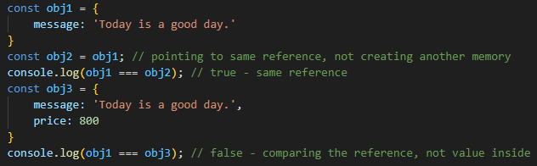

Obj1 and obj2 Obj2 and obj3

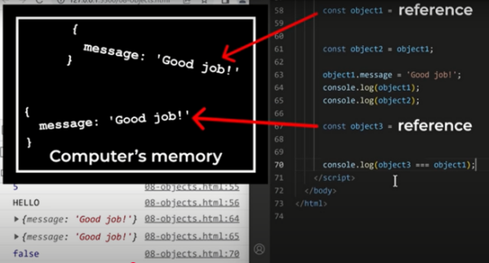 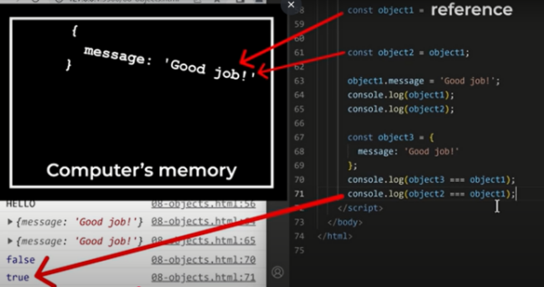

Comparing the references, not the value inside

**Object Example 1:**

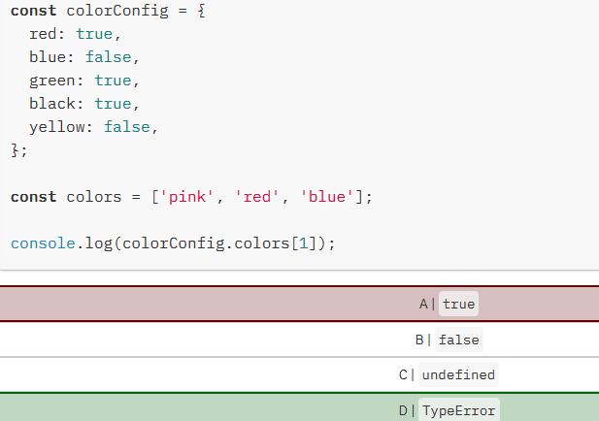 

In JavaScript, we have two ways to access properties on an object: **bracket notation**, or **dot notation**. In this example, we use **dot notation** (**colorConfig.colors**) instead of bracket notation (colorConfig["colors"]).

With dot notation, JavaScript tries to find the property on the object with that exact name. In this example, JavaScript tries to **find a property called colors on the colorConfig object**. There is **no property called colors**, so this **returns undefined**. Then, we try to **access the value of the first element by using [1]**. We **cannot do this on a value that's undefined, so it throws a TypeError**: Cannot read property '1' of undefined.

JavaScript interprets (or unboxes) statements. When we use bracket notation, it sees the first opening bracket [ and keeps going until it finds the closing bracket ]. Only then, it will evaluate the statement. If we would've used colorConfig[colors[1]], it would have returned the value of the red property on the colorConfig object.

**Object Example 2:**

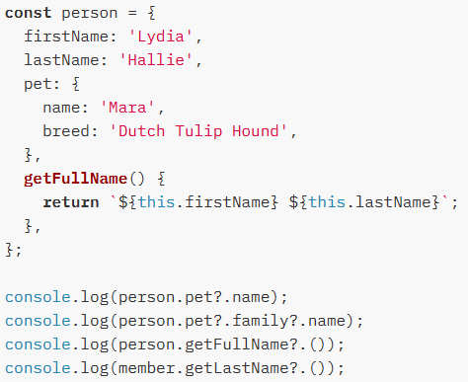 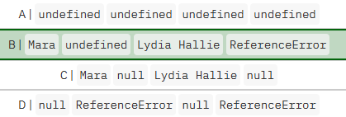

With the optional chaining operator?., we no longer have to explicitly check whether the deeper nested values are valid or not. If we're trying to access a property on an **undefined**or **null value** (nullish), the expression short-circuits and **returns undefined**.

**person.pet?.name:** person has a property named pet: **person.pet is not nullish**. **It has a property called name, and returns Mara**.

**person.pet?.family?.name**: person has a property named pet: person.pet is not nullish. pet does not have a property called family, person.pet.family is nullish. **The expression returns undefined**.

**person.getFullName?.(**): person has a property named getFullName: person.getFullName() is not nullish and can get invoked, which returns Lydia Hallie.

**member.getLastName?.()**: variable member is non-existent therefore a ReferenceError gets thrown!

**Auto-Boxing in JS**

Boxing is the process where JavaScript automatically wraps a primitive value (like a string or number) inside its corresponding object wrapper (like String, Number, etc.) so that it can use object methods. Boxing doesn’t happen to null & undefined.

**Primitive datatype don't have properties and methods like object.**

Example 1: Autoboxing with Strings

**console.log('Hello Bye'.length);**

**console.log('Hello Bye'.toUpperCase());**

**What happens internally?**

JavaScript autoboxes "hello Bye" into a String object. It calls .length and .toUpperCase() on the temporary object.

The object is discarded after the operation.

Example 2: Autoboxing with Numbers

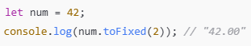 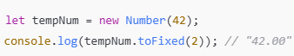 //this is how it works

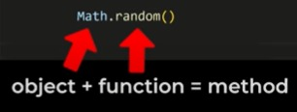 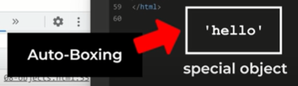

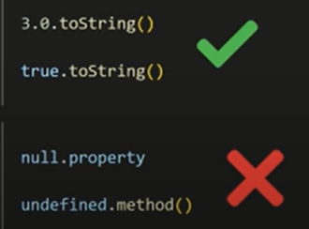

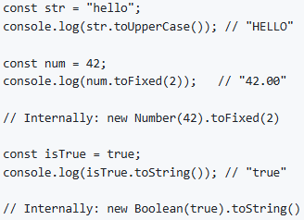

**Repeat String**

In JavaScript, you can repeat a string multiple times using the String.prototype.repeat method.

Syntax: string.repeat(count));

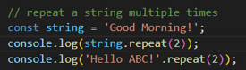 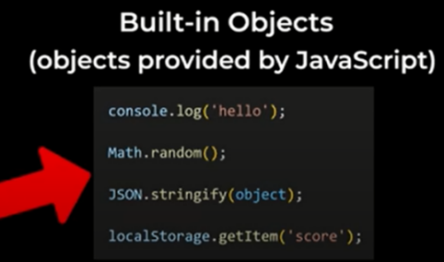

**Arrays**

An **array** is a special data structure in JavaScript that can store multiple values in a single variable. It can hold different data types, including numbers, strings, objects, and even other arrays. Arrays in JS are zero-indexed.

Arrays are another type of value and they represent a list of values.

**Types of Arrays**

* **Numeric Arrays**



* **String Array**



* **Mixed Array**



* **Nested Array** (Array inside another array)

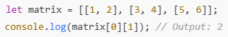

**Accessing Elements**

You can access array elements using their **index** (starting from 0).

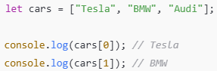

**Modifying an Array**

Change an Element

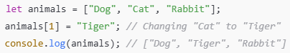

Add a new Element



**Add and Remove Elements**

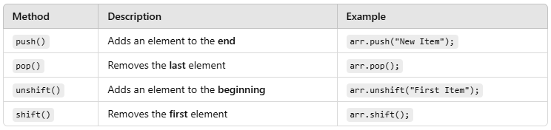

.**push()** - **adds a value** to the **end of the array**.

.**pop()** - **removes a value** from the **end of the array**.

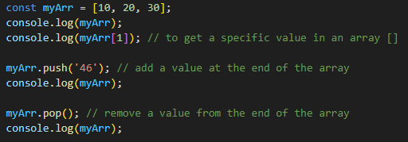 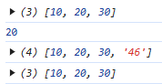

.**unshift()** - **adds a value** to the **start of the array**.

.**shift()** - **removes a value** from the **start of the array**.

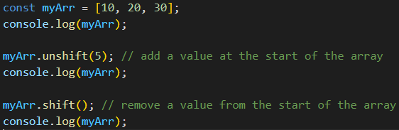 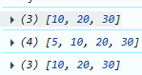

Consider example: const array1 = [1,2,3];

This variable doesn’t contain value as 1,2,3. This array is stored somewhere in computers memory and this variable only contains a reference that points to where array is in the memory.

array2 = array1;

If we create a copy of array1, array2 doesn’t contain copy of array1 values. It just contains the copy of the reference. So, both variable pointing to same array.

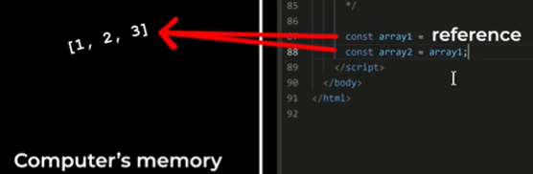 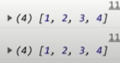

array2.push(4);

console.log(array1); //1,2,3,4

console.log(array2); //1,2,3,4

That’s because arrays are references. So both of these point to the same array in memory.

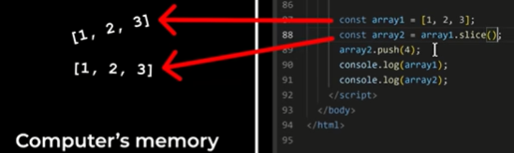 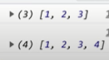

To avoid this, we can create a copy of the values in the array using slice() method.

This will make a copy of the values in array1 and now these two variables points two different arrays.

**Modifying an Array Finding Elements**

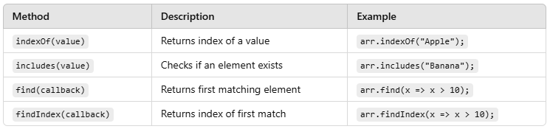

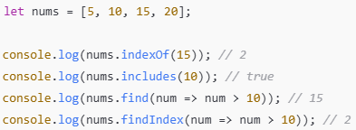

**Array Methods**

A .**splice() - removes a value from an array.**

Modifies the original array by **removing**, **adding or replacing** elements.

Splice takes two values:

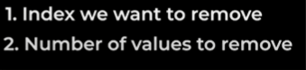

Syntax



* **start:** The index at which to start changing the array.
* **deleteCount:** The number of elements to remove.
* **item1, item2, ... (optional):** Elements to add to the array, starting at the start index.

**Modifies the original array.**

Returns an array containing the removed elements.

**Removing elements**

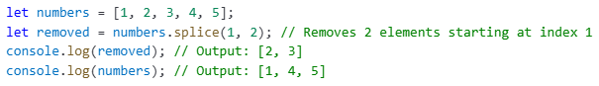

**Adding and Replacing elements**

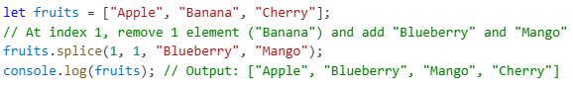

B .**slice() -** method returns selected elements in an array, as a new array.

Method extracts **elements** **from an array** and returns a **new array** without modifying the original array.

Syntax



* **start:** The beginning index (inclusive).
* **end:** The ending index (exclusive). If omitted, slice extracts till the end of the array.

**Does not modify** the original array.

Returns a new array containing the selected elements.

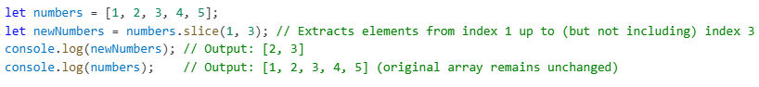

**Summary**

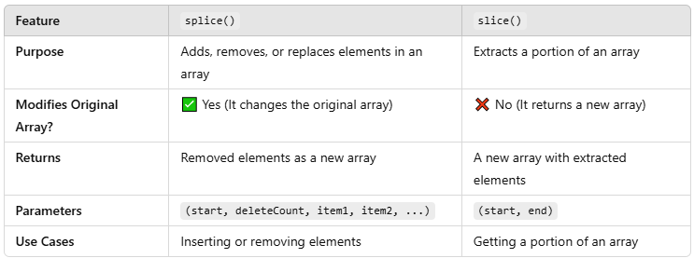

**Set**

A Set in JavaScript is a built-in object that **stores unique values**. It **removes duplicates automatically** and can store any type of data (numbers, strings, objects, etc.).

**Creating a Set**

You can create a Set using the new Set() constructor.



Or initialize it with values



**Methods**

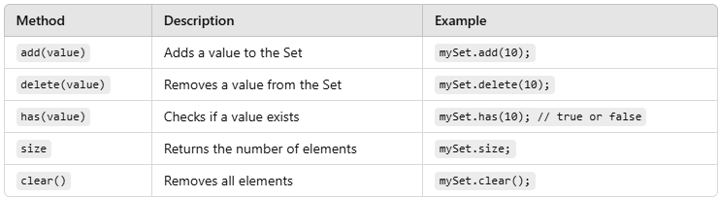

Example

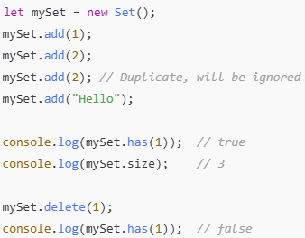

**Converting Set to Array**

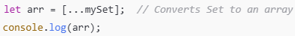

Removing Duplicates from an array

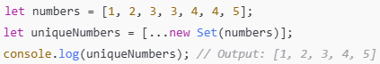

Tracking Unique Users in a Chat App

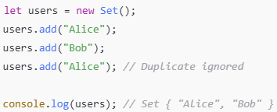

**Useful for filtering duplicates, tracking unique values, and more.**

**Looping through an Array**

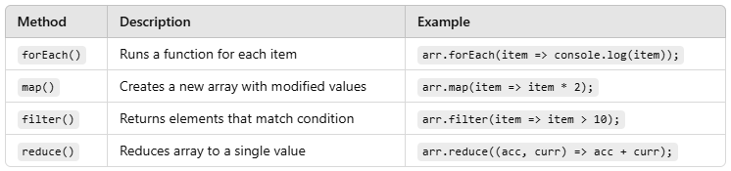

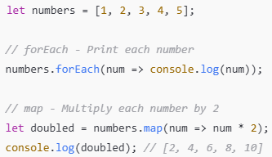 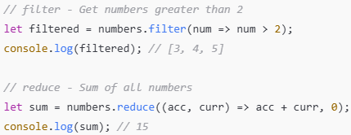

**1. forEach** - foreach will loop through the array and for each of this values, it will save the value in the param and run the function

 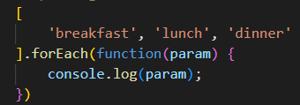 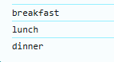

So basically, this will take the first value, save it in the param and run the function and so on.

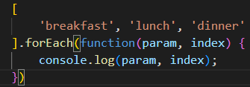

We can also give 2nd parameter and that is index

We can also give index to the forEach

**Note: forEach methods don’t have continue unlike for loop**

Ex: If value is ‘wash dishes’, skip it

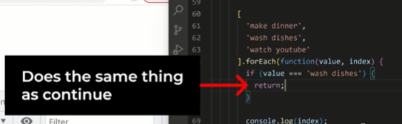

Return statement does the same thing as continue - return statement will end the function and run the next function iteration.

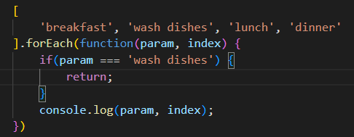 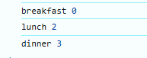

Break statement is difficult to execute using forEach.

If we need to use break using forEach loop, then its better to use regular for loop

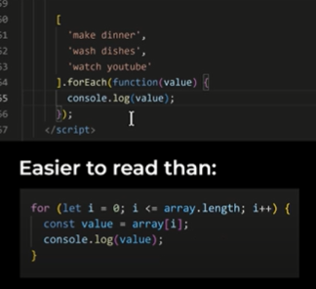

**Map, filter and reduce are higher order functions.**

**1. map()** method – transform an array into another array

It is used to create a new array by applying a specified function to each element in an existing array.

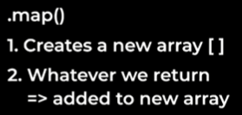

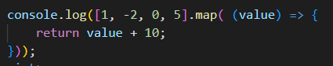 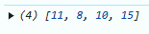

**2. .filter()** method works the same way as forEach.

It is used when we want to filter the array to obtain required value

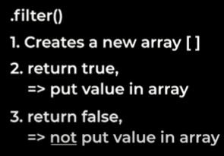

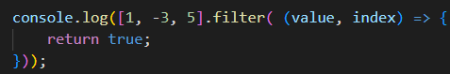 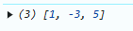

All the values will be added into the new array

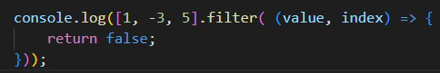 

All the values will not be added into the new array

Ex: to return only positive numbers

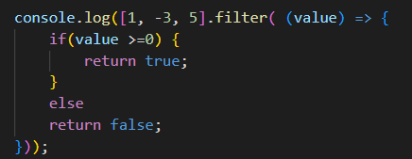 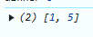

Shortcut of above code

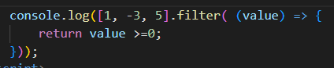

1. **reduce() -** is used when we want to reduce the array to single value eg (max, min, avg, sum, difference etc).

reduce passes two arguments one function(which includes accumulator and initial value as argument itself) and another initial value of accumulator.

**Sorting and Reversing Arrays**

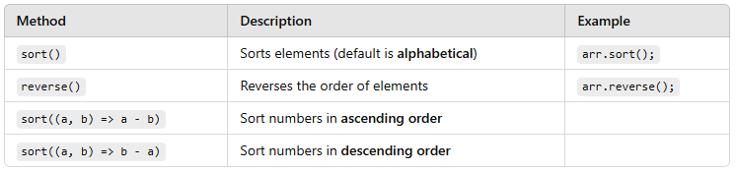

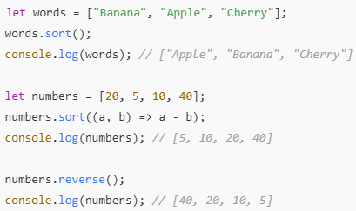

**Loops**

Loops in JavaScript are used to execute a block of code multiple times. The two most commonly used loops are:

**1. for loop** - The **for** loop is used when we know how many times we need to execute the loop.

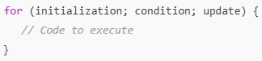

**Initialization**: Runs once before the loop starts (e.g., let i = 0).

**Condition**: Checked before each iteration; loop runs while it's true.

**Update**: Executes after each loop iteration (e.g., i++).

**Counting from 1 to 5 Loop through an array**

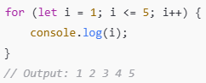 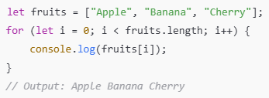

**2. while loop** - The while loop is used when we **don’t know** the number of iterations beforehand. It keeps running until the condition becomes **false**.

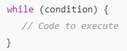

**Condition**: The loop runs while this condition is true.

**Counting from 1 to 5 keep asking for correct input**

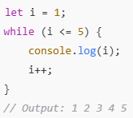 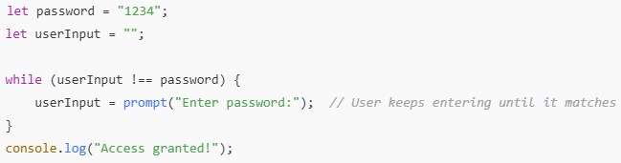

**3. do while loop** - The do...while loop is similar to while, but it executes at least once, even if the condition is false.

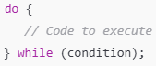 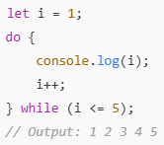

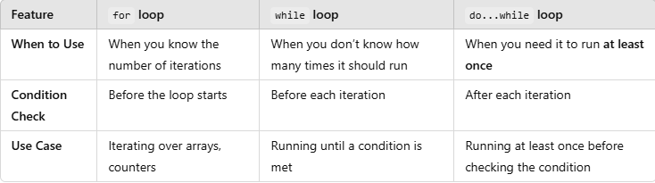 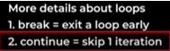

**Execution Context in JS**

***Everything in JS happens inside an Execution Context.***

Whenever any JavaScript code is executed a global execution context is created.

An **Execution Context** is like a box which has two components called Memory Component and Code Component.

1. **Memory Component**:

This is where all the variables and functions are stored as a key value pairs. Memory component also known as variable environment.

**2. Code Component:**

This is the place where whole JS code is executed. TOE is just like a thread in which whole code is executed one line at a time. Code component is also known as thread of execution.

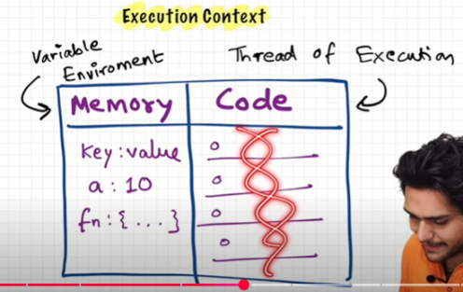

***JavaScript is a synchronous single-threaded language.***

It has one call stack and it can only do one thing at a time. This call stack is present inside the JS engine. And all the code is executed inside the call stack.

When the JavaScript engine starts executing the script, **the Global Execution Context (GEC)** is created in **two phases:**

**1. Creation Phase (memory creation phase):**

In this phase, JS scans the entire code and memory is allocated for all functions and variables which are present in the global scope. Special keyword **undefined** is stored for variables and for functions literally the whole function (code).

This context consist of Global object (window), this keyword (refers to the global object).

Consider with example, for variables it stores special value as **undefined** and for functions it stores whole **function code.**

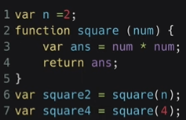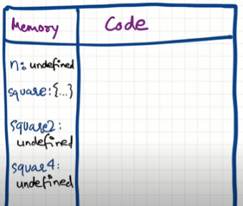

**2. Code Execution Phase:**

In this phase, JS code is executed line by line. And the variables are updated with their actual values.

Now when JS encounters n=2 code, the **value 2** is assign to the variable **n**. Now, n is updated in the global memory. At line 2, function **square** was already stored in the memory during the creation phase, so nothing changes here. At line 6, we invoke a function. Function square2 is called with the argument n.

**Function invoke**: Whenever we see a function name with parenthesis, it means the function is now being executed.

Whenever a function is invoke, a brand new **execution context (FEC) is created** and pushed into the call stack. The same Creation and Execution Phases happen inside the function’s context. And it follows the same process. Refer image for the memory allocation in the FEC.

When the return keyword is encountered inside a function, it signals that the function's execution is complete. The control of the program then returns to the point where the function was called, and the function’s Execution Context is removed (popped) from the Call Stack.

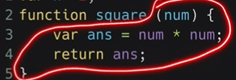 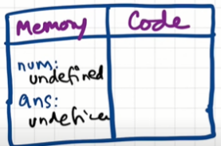 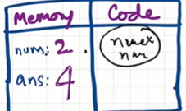 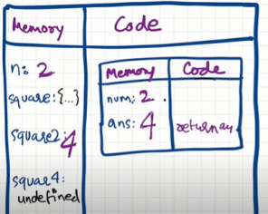

At line 7, follows the same step and **everything is executed and program is finished and now GEC is also deleted.** Everything will be cleared from the call stack.

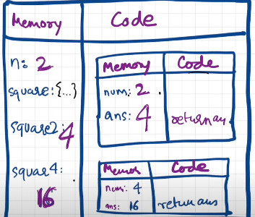 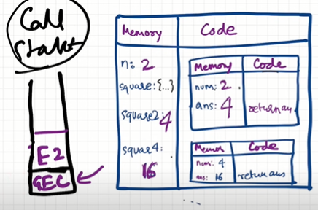

**This is known as call stack.** Call Stack is basically a ***stack which maintains the order of execution of execution context.***

The **Call Stack** manages Execution Contexts. The call stack is a data structure that keeps track of the function calls in your code. It follows **Last In, First Out (LIFO)** principle, meaning the last function that gets pushed onto the stack is the first one to be popped off when the function completes

When JS code runs, the **Global Execution Context** is pushed onto the stack. Each function call creates a new **Function Execution Context** that is also pushed onto the stack. When a function finishes executing, its Execution Context is popped off the stack. Finally, when all code finishes, the **Global Execution Context** is also removed.

Also known as Execution Context Stack, Program Stack, Control Stack, Runtime Stack, Machine Stack.

**Global Execution Context (GEC):**

This is the default context created when the script first loads in the browser. It handles code that is not inside of a function.

**Function Execution Context (FEC):**

This is created whenever a function is called. Each function call has its own execution context.

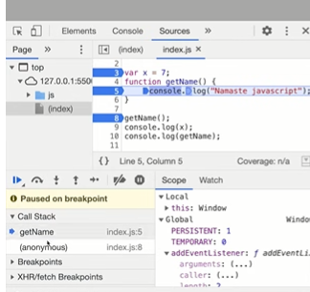

You can see in image how call stack look like. Anonymous is GEC. getName is FEC.

**In simple words,**

JavaScript creates a Global Execution Context first.  
When a function is called, a Function Execution Context is created and pushed onto the Call Stack.  
Functions execute line-by-line. Once finished, the Execution Context is popped off the Call Stack.  
This process helps JavaScript run code sequentially and manage function calls.

**1. Primitive Types – are stored directly in stack memory**

Each primitive value is copied **by value**, meaning a new copy is made when assigned to anther variable.

Same behaviour as C/C++, Java for primitive types.

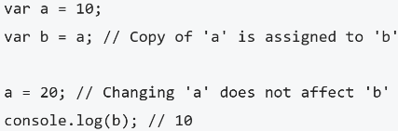

2. **Object, Arrays and Functions – are stored by reference in heap memory.**

The actual object is stored in heap memory. The variable stores only a reference (memory address) in stack memory.

When assigned to anther variable, only the reference is copied, not the actual data.

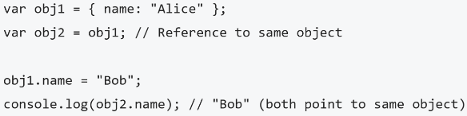

**Shortest Program**

Shortest Program in JS is **Empty file**.

Even if you run an **empty JavaScript file** — yes, **completely blank** — **something still happens behind the scenes**!

Wherever JS runs, the JavaScript engine (for example, Chrome's **V8 engine**) will **automatically** create:

A **Global Object** (window in browsers), A **Global Execution Context (GEC),** A **this keyword**, which refers to the **Global Object** in the global scope.

**JS can run not just in browsers** (Chrome, Firefox) but **also on servers** (like Node.js) or other devices.

In browsers, the global object is called **window.** In Node.js, it's called **global.**

**Global Space** simply means:

Anything that is **NOT inside a function** is said to be in **global space.**

At the global level,

**this === window** // true

Means, in the browser, **the this keyword refers to the window object** when you're outside any function

**Undefined vs not defined**

**Undefined**: A variable is **undefined** when it has been declared but has not been assigned a value.

When a variable or function has been declared, it is considered defined. It is kind of placeholder for any type of value before that it is undefined.

When the JavaScript engine starts executing the script, the first step is creating the Global Execution Context. During the Creation Phase, memory is allocated for variables and functions so it’s defined but their value is undefined.

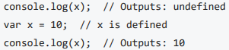

**Not defined**: A variable is **not** **defined** when it has not been declared at all. Attempting to access a variable that is not defined results in a **ReferenceError**.

When the JavaScript engine starts executing the script, value that we have access first it checked inside memory. If it’s found than we can access that else get ReferenceError.

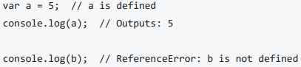

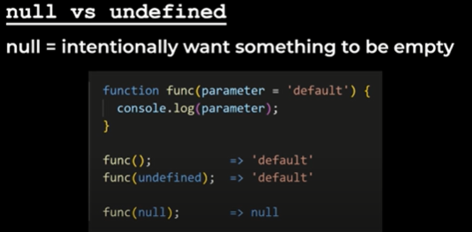

**Browser, Web APIs, Call Stack, Queue**

The **browser** (like Chrome, Firefox, etc.) has many parts inside it.

One important part inside the browser is the **JavaScript Engine** (like **V8** in Chrome).

Inside the **JS engine**, there is a **Call Stack**. The Call Stack is where JavaScript manages the order of function calls and execution.

But the browser has much more than just the JS Engine!

It also provides other features like: **Local Storage** (save data locally), **Timers** (setTimeout, setInterval), Networking (HTTP, HTTPS, URLs), **Web APIs** (console, DOM, location, fetch, etc.)

These extra features (called **Web APIs**) are **not part of the JavaScript engine itself**, but the browser **gives them to JavaScript** when needed.

**JS Engine:** Executes pure JavaScript code.

**Browser (outside JS Engine):** Gives "superpowers" like timers, networking, DOM manipulation, etc.

JavaScript **uses** these browser-provided Web APIs to do extra tasks (example: wait for 2 seconds, make network requests, show something on the page).

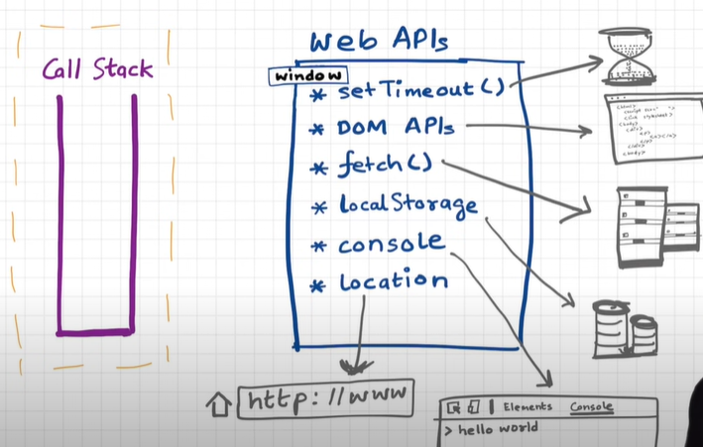 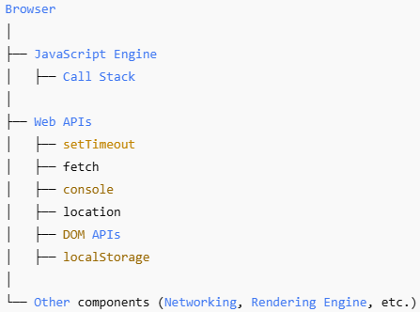

**Callback Queue** (Task Queue, Macrotask): The callback queue, also known as the task queue, holds tasks (callbacks or events) that are ready to be executed. These tasks usually come from asynchronous operations, such as DOM events, HTTP requests, or timers.

**Event Loop:** The event loop is responsible for continuously checking the call stack. If the call stack is empty, the event loop takes the first task from the callback queue and pushes it onto the call stack for execution.

**The Event Loop** is how JavaScript handles **asynchronous operations** (like setTimeout, API calls, etc.) even though JavaScript is **single-threaded** (one operation at a time).

It **manages** tasks between the **Call Stack** and the **Task Queue** to keep your app running smoothly.

Example:

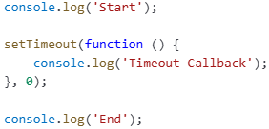 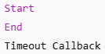

console.log('Start') → runs immediately → prints **Start**

setTimeout is sent to **Web APIs** → timer starts → function is registered.

console.log('End') → runs immediately → prints **End**

After timer finishes (even 0 ms), the callback moves to **Callback Queue.**

**Event Loop** sees Call Stack is empty ➔ moves callback to Call Stack ➔ prints **Timeout Callback.**

Microtasks (like Promise.then()) are handled **before** normal Callback Queue tasks (like setTimeout)

**Microtask Queue**: The microtask queue holds tasks that are also ready to be executed but has a higher priority than the callback queue. Microtasks are usually scheduled by JavaScript promises, mutation observer callbacks, and other similar mechanisms.

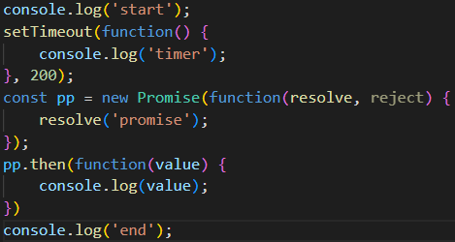

In above example, even though the timer associated to setTimeout will be 0, the higher priority will always lbe given to microtask queue.

**Here's how they work together**:

When an asynchronous operation is encountered, such as a **setTimeout** or a **Promise**, the callback associated with that operation is sent to the **appropriate queue-**

* For Promises, the callback goes to the **Microtask Queue** after the Promise settles.
* For setTimeout and similar, the callback goes to the **Callback Queue** (Macrotask Queue) after the specified time.

When the **Call Stack** is empty (no functions being executed), the **Event Loop** first checks the **Microtask Queue.**

* If the Microtask Queue has tasks, it moves the first one to the Call Stack and executes it.
* If the Microtask Queue is empty, the Event Loop checks the **Callback Queue** and moves a task from there to the Call Stack.

This process keeps repeating, allowing JavaScript to handle asynchronous operations efficiently **without blocking the main thread.**

**JS run time environment**

Think of **JS Runtime Environment** like a big "container" that has:

The **JS Engine** (main component that actually runs JavaScript)

Some **APIs** (like setTimeout, DOM APIs, fetch, etc.)

**Event Loop**, **Callback Queue**, **Microtask Queue** (to handle asynchronous tasks)

Without a JS Engine, a runtime environment can't exist. JS Engine is the **heart** of the JS runtime.

Each **browser** (Chrome, Firefox, Safari) comes with its own JS runtime environment.

Example, Chrome has **V8 Engine** inside its JS runtime. Firefox has **SpiderMonkey**.

**JS engine**

**JS Engine** is a **program (piece of code)** that takes your JavaScript and **runs it**. It is not a physical machine.

When JS Engine receives your JavaScript code, it does 3 things:

Process includes **Parsing ---> Compilation -----> Execution**.

1. Parsing: the engine reads your code breaks it down into small tokens and converts it into AST (Abstract Syntax Tree).

Example: let a = 6; let-token, a-token, =-token, 6-token

astexplorer.net – shows AST generated code (to understand more how AST code behaves).

**Interpreter** – it takes the code and start executing line by line. It is fastly executed and it does not have to wait first to compile. Immediately starts executing line by line.

**Compiler** – whole code is compiled first even before executing. The code is compiled and new code is formed which is the optimized version of this code. And this code runs. It has more efficiency.

1. **Modern JavaScript Engines** (like V8) use **JIT compilation**.

They **both compile and interpret** at the same time to give **speed + efficiency**.

First, code is interpreted into **Bytecode.**

While executing, the compiler **optimizes** the code wherever possible.

AST goes to interpreter. Interpreter converts high level code to byte code and code moves to the execution step. While doing this, it takes the help of the compiler.

Job of compiler is to optimize the code as much as it can on the run time.

1. Execution: after bytecode is ready, **execution** happens.

Two important things are used here.

Memory Heap: A place to store variables, objects, functions (like a large warehouse).

Call Stack: Keeps track of **what function is currently running** and **what will run next**.

During execution, the **Garbage Collector** runs to clean memory that is no longer needed.

Additional optimizations during execution include:

**Inlining:** Replace a function call with the function’s body if possible.

**Copy Elision:** Avoid unnecessary copying of data.

**Inline Caching:** Speed up access to object properties.

**Functions**

A JavaScript function is a block of JavaScript code that can be executed when "called" for.

For example, a function can be called when an **event** occurs, like when the user clicks a button. Function is a block of reusable code. In JS, functions are treated as objects and can be assigned to variables, passed as arguments, or returned from other functions.

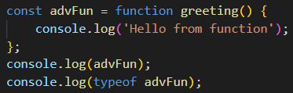 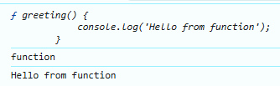

We can also run the function inside the variable.

advFun();

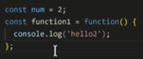

As long as we access the function (using variable), function name is not required.

Anonymous function – function without a name.

**Advantages of Regular functions**:

1. Easier to read
2. Hoisting - we can call the function without even before we have created it. Hoisting doesn’t work when we have created the function using variable.
3. **Function - save a value in an object**

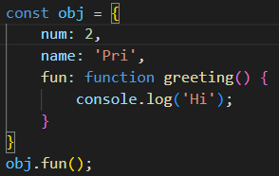

This is known as method (function saved inside an object)

1. **Function - pass a value into a function**

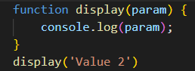

1. **Function - pass a function into a function**

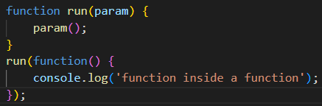

**Arrow Function**

A shorter way to write functions introduced in **ES6 (2015)** (mostly works the same way as a regular function)

**Shortcuts of Arrow function**

1. one parameter value – we can pass parameter without brackets

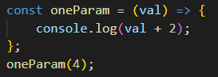 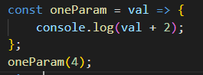

1. **One line return value**

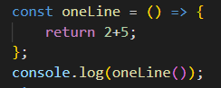 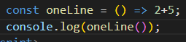

Difference between regular and arrow function

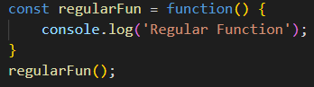 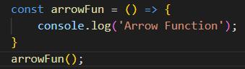

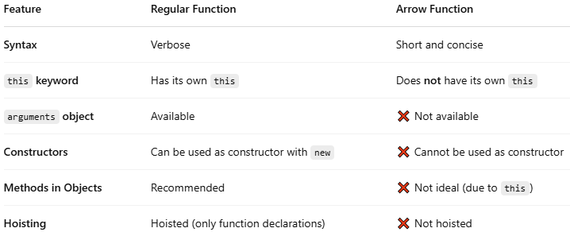

1. **Arrow functions do not bind their own this**, they inherit it from the **parent scope**.

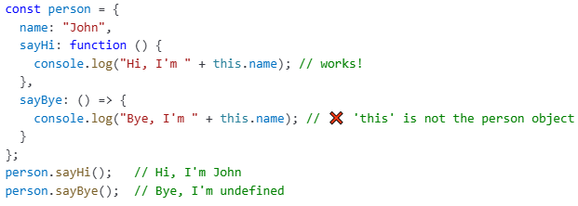

2. If you need **arguments**, don't use arrow functions.

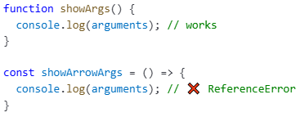

**Function Statement/ Declaration vs Function Expression**

**Function Statement/ Declaration**: A normal function that we create using Naming convention. And by this we can do the **Hoisting**.

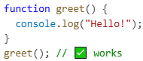 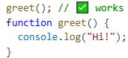

**Function Expression**: when we assign a function into a variable that is Function Expression. And we cannot do Hoisting by this because it acts like variable.

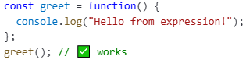 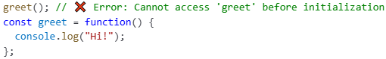

**Name Function Expression**: A function with a name is known as Named Function Expression. It’s a function **expression** (assigned to a variable) **but with a name** given to the function itself.

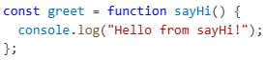

greet is the **variable** holding the function. sayHi is the **name of the function** inside it.

**Anonymous Function**:

A Function without the name is known as Anonymous Function. They does not have their own identity.

When we run, it gives error as according to ES version, function should have a name.

It’s often used when you want to define a function **on the fly**, especially as a **callback** or inside a **function expression**.

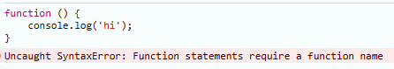

**Parameters vs Arguments**

**Parameters**: when we creating a function & put some variable in this ( ) that is our Parameters.

The function which get labels or identifiers are known as parameters.

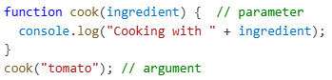

**Arguments**: when we call this function & pass a variable in this ( ) that is our Arguments.

The values which we pass inside a function are known as arguments.

**First Class Function**

In JavaScript, a first-class function means a function can be treated like any other variable.

First class functions have the ability to:

1. Be assigned to variables.

2. Be passed as arguments to other functions.

3. And be returned from other functions.

This feature enables powerful programming patterns like callbacks, higher-order functions, and function composition.

Because of this, we say: "**Functions in JavaScript are first-class citizens**."

**Higher-Order Functions**

A Higher-Order Function (HOF) is a function that does one or both of the following:  
1. **Takes another function as an argument**.  
2. **Returns a function as its output**.

**Why?**

Makes code more reusable and readable.

Helps with functional programming (like map, filter, reduce).

Allows writing concise and powerful logic.

Example 1: Function Taking another Function as Argument

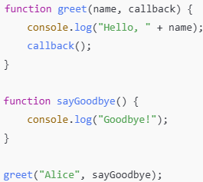 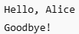

Here, **greet is a higher-order function** because it takes **sayGoodbye** as a parameter.

Example 2: Function Returning another Function

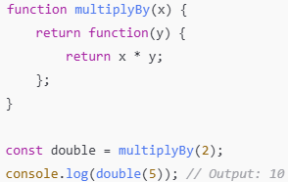

Here, **multiplyBy** returns another function, making it a higher-order function.

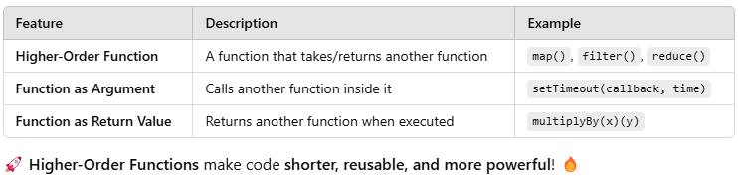

**IIFE (immediately Invoked Function Expression)**

An **IIFE (Immediately Invoked Function Expression)** is a function that **executes immediately after being defined.**

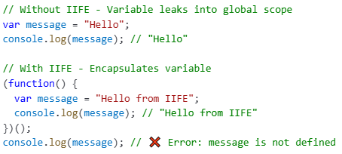

**Why**? The message inside the IIFE is **private** and doesn’t affect the global message.

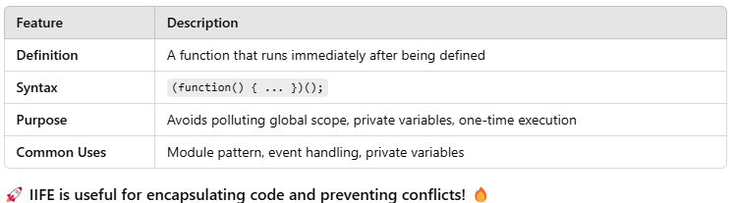

**Scope, Scope Chain and Lexical Environment**

**Scope** means where you can access a variable or function in your code.

It decides **which part of the code** can use a variable.

**Lexical Environment?** Every time **an Execution Context** is created, **a Lexical Environment** is also created.

**Lexical Environment** contains:

**Local Memory**: Variables/functions declared in the current function.

**Reference to Parent’s Lexical Environment**: (i.e., where the function is physically written in the code.)

**Lexical** means in order or hierarchy — based on where things are written (not when they are called)

How Scope Chain works?

When JS tries to find a variable:

* It **first looks in the current function’s local memory**
* If **not found**, it **moves up to the parent’s Lexical Environment.**
* If **still not found**, it **keeps moving up** step-by-step in the Lexical Environment chain.
* If nowhere found, then it says "**variable not found**" (ReferenceError).

This **chain of environments** is called the **Scope Chain.**

Thus, **Scope Chain** helps in resolving variables by traversing through the hierarchy of Lexical Environments.

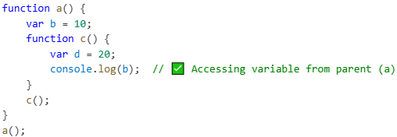

Here, c() can access: its **own local memory** (d), and its **parent a()'s memory** (b), and finally **global memory** if needed.

Ex: lexical environment of a? local memory along with lexical env of parent (here it is global).

Ex: lexical environment of c? local memory of c along with lexical env of (a) along with lexical env of its parent (a’s parent). Here c has access to all these variables and functions  
**lexical environment** **of a lexical environment** **of c**

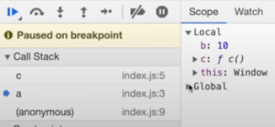 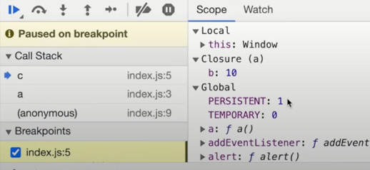

Imagine you **lost your phone** at home.

1. You **first search your own room**

(*this is like checking your* ***current function’s local memory****.*)

1. You **don't find it**, so you go check the **living room**   
   (*this is like checking the* ***parent function’s memory****.*)
2. Still **no phone**, so you **move to the kitchen**   
   (*this is like checking the* ***grandparent’s memory****.*)
3. If not found even there, you **go to the backyard**   
   (*this is like finally checking the* ***global environment****.*)
4. If it’s **nowhere**, you accept that "**phone not found**"   
   (*this is like JavaScript throwing a* ***ReferenceError****!*)

**Key Point: Lexical Environment** = Local memory + Reference to Parent's Lexical Environment.

**Scope Chain** = The path JavaScript engine follows when looking for a variable (current → parent → grandparent → … global → null)

**Closure**

Function bundled with its lexical environment is known as a closure. Functions that can capture and remember their surrounding state.

A closure in JavaScript is a function that has access to the variables and parameters of its outer (enclosing) function, even after the outer function has finished executing.

**How closures are created?** Closures typically occur when a function is defined inside another function. The inner function maintains a reference to its lexical environment, capturing the state of the outer function at the time of its creation.

Whenever function is returned, even if it’s vanished in execution context but still it remembers the reference it was pointing to. It’s not just that function alone it returns but the entire closure.

**Advantages:**

**1. Data Encapsulation and Private**

Closures enable you to create private variables that can't be accessed or modified from outside the function. This helps in protecting the data from unintended changes.

Closures help retain **state** between function calls without using global variables.

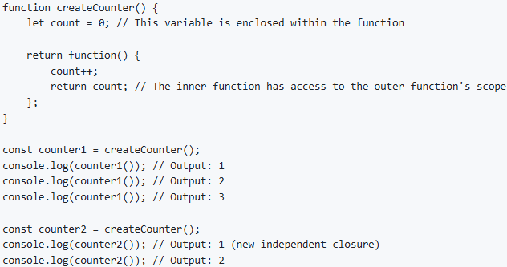

Closures let you **hide variables** from the outside world — just like private variables in OOP

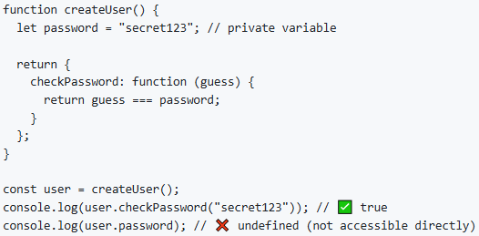

**2. Callback Functions**

Closures are often used in asynchronous programming where a function needs to remember variables from its context.

**3. Event Handlers**

When writing event listeners, closures help ensure that handlers can access variables that were in scope when the handler was created.

**4. Memorization and Function Currying**

**Disadvantages**:

The variables declared inside a closure are not garbage collected.

Too many closures can slow down your application. This is actually caused by duplication of code in the memory.

Over consumption of memory. Every time a closure is formed it consumes a lot of memory which cannot be deleted so this acts as a disadvantage.

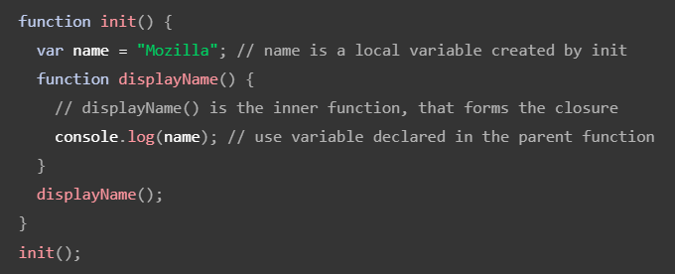

init() creates a local variable called name and a function called displayName(). The displayName() function is an inner function that is defined inside init() and is available only within the body of the init() function. Note that the displayName() function has no local variables of its own. However, since inner functions have access to the variables of outer functions, displayName() can access the variable name declared in the parent function, init().

**Real time example** - From <<https://blog.devgenius.io/a-real-time-example-of-javascript-closure-b10687d66e72>>

In the top picture you can see one lady is buying oranges from an outside trolley. Imagine it’s an outer function where oranges are a variable. That lady brings those oranges to home. Now you think she is inside inner function. Now she wants to have a glass of orange juice. So she cuts few oranges and squash it and pour it in a jar. In this process she is returning a juice served in a glass closure within buying oranges.

Always remember closure captures variables from lexical scope.

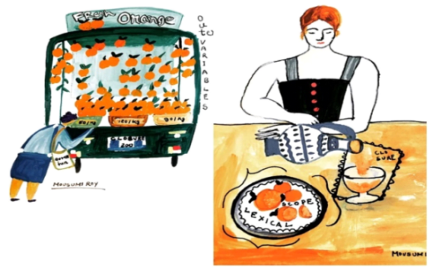

Now if I write the whole process programmatically how it will look?

function buyOrange () {

let fruit = “oranges”; // lexical scope

function prepareJuice() {

debugger

Console.log (“Let’s Squash:” +fruit+ “& juice is ready”); // closure

}

return prepareJuice;

}

Const serveJuiceInAGlass = buyOrange();

serveJuiceInAGlass();

**Garbage Collector**

**Garbage collection** is the process of **automatically freeing up memory** that's no longer being used by the program.

You don’t need to **manually delete** variables like in C or C++ — JavaScript handles it for you!

JavaScript uses a concept called **"Reachability"**

If a value is **reachable** (can still be accessed or used), it stays in memory.  
If it becomes **unreachable**, the garbage collector removes it to free up memory.

Example:

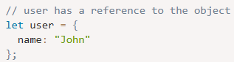 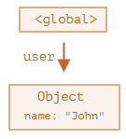

Here the arrow depicts an object reference. The global variable "user" references the object {name: "John"} (we’ll call it John for brevity). The "name" property of John stores a primitive, so it’s painted inside the object.

If the value of user is overwritten, the reference is lost:

user = null;

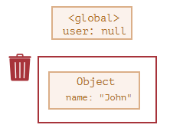

Now John becomes unreachable. There’s no way to access it, no references to it. Garbage collector will junk the data and free the memory.

Now let’s imagine we copied the reference from user to admin

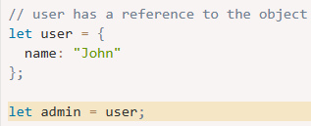 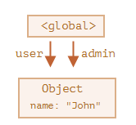

Now if we do the same:

user = null;

Then the object is still reachable via admin global variable, so it must stay in memory. If we overwrite admin too, then it can be removed.

**addEventListener and onclick**

both **addEventListener**() and **onclick**are used to handle events like clicks, but they function differently.

While **addEventListener() allows multiple event listeners** and better control over event propagation, **onclick is limited to a single event handler** and gets overwritten.

**addEventListener**

The [addEventListener()](https://www.geeksforgeeks.org/javascript-addeventlistener-with-examples/" \t "https://www.geeksforgeeks.org/difference-between-addeventlistener-and-onclick-in-javascript/_blank) method attaches an event handler to the specified element. Any number of event handlers can be added to a single element without overwriting existing event handlers.



Parameters:

**event**: what type of interaction we want to listen for (ex: click, keydown. Keyup, etc). Event can be any valid JavaScript event. Events are used without the “on” prefix like using “click” instead of “onclick” or “mousedown” instead of “onmousedown”.

**listener**(handler function): A function we want to run

**useCapture**:  (Optional parameter) A Boolean value that specifies whether the event should be executed in the capturing or in the bubbling phase.

**Example**: We add 2 event listeners to a button. When clicked, it updates the content of two <h1> elements with ‘Task1 is performed’ and ‘Task2 is performed’.

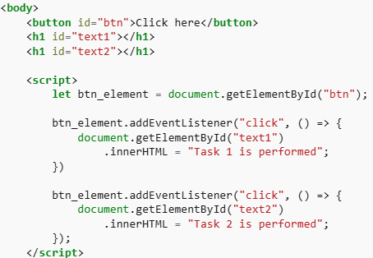 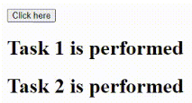

**onclick**

The [onclick event](https://www.geeksforgeeks.org/html-dom-onclick-event/" \t "https://www.geeksforgeeks.org/difference-between-addeventlistener-and-onclick-in-javascript/_blank) in JavaScript is triggered when a user clicks on an HTML element, such as a button. It can be used to execute a specified function or piece of code in response to the user’s click action.

**HTML**  **JavaScript**

 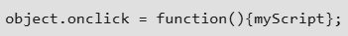

The onclick is just a property. Like all object properties, if we write more than one property, it will be overwritten.

**Example**: we attaches two onclick event handlers to a button. However, only the second event will execute, as the second onclick overwrites the first one, updating only the second <h1> element.

https://www.geeksforgeeks.org/difference-between-addeventlistener-and-onclick-in-javascript/

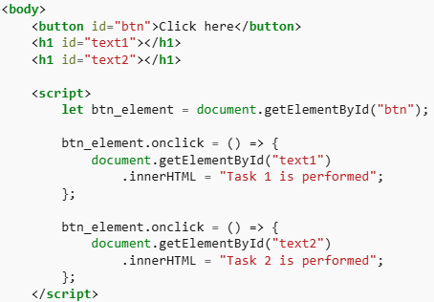 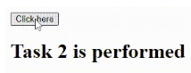

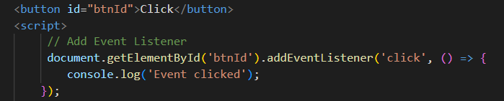

**Advantages of addEventListeners**:

1. Multiple event listeners for an event

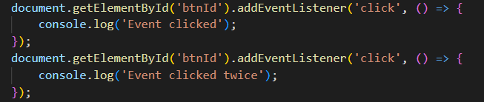

We can also remove an event listener using **removeEventListener**()

removeEventListener also takes 2 parameters:

Event and which function needs to be removed

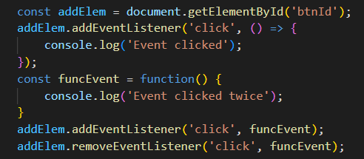

**Best Practice: use .addEventListener instead of onclick=”…”**

**Why to remove event listeners?**

Event listeners consume a lot of memory which can potentially slow down the website therefore it is good practice to remove if it is not used.

**setTimeOut Method**

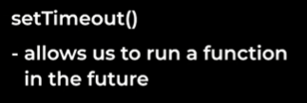

Calls a function after number of milliseconds.

**Used to execute a function once after a specified delay.**

setTimeout stores the function (callback) in a different place and attaches a timer to it, when the timer is finished it rejoins the call stack and executed. Till that time JS doesn’t wait. It executes the other lines of code.

This takes 2 values:

1. A function we want to run in the future.
2. How long to wait before running this execution ( 1sec = 1000 milliseconds)

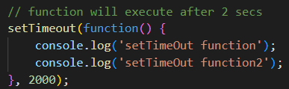

**This is known as asynchronous code.**

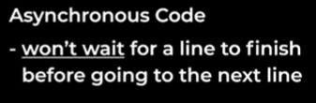 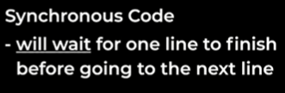

**All other codes are synchronous code.** Even function which is present inside settimeout will execute line by line.

Example 1:

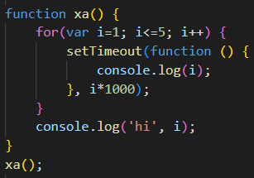 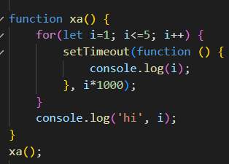

In this example, using var, it makes copy of the function, attaches a timer and also remembers the reference of a variable I, not the value. Similarly 5 copy of these functions are pointing to same reference to i. it refers to the same memory space.

JS does not wait for anyone, it runs the loop again and again. setTimeout will store the 5 functions and JS will move on and will not wait timer to expire. When the timer expires it is too late and the loop was continuously running, the value of i is now 6. So now when callback function runs that time in memory location, the value is 6. All of these 5 functions are referring to same spot in memory.

A quick way to solve this issue is to use **let as it is a block scope** and for each loop iteration **new i will be created**. And each time setTimeout is run, this callback function has new copy of i with it. So each time it is run, it is referring to different memory location.

If interviewer ask to solve using var only, not using let. We need to form a closure. When we enclosed setTimeout function into a function y, it will create new EC and will store the value of i.

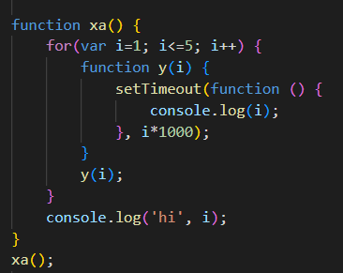

Example 2:

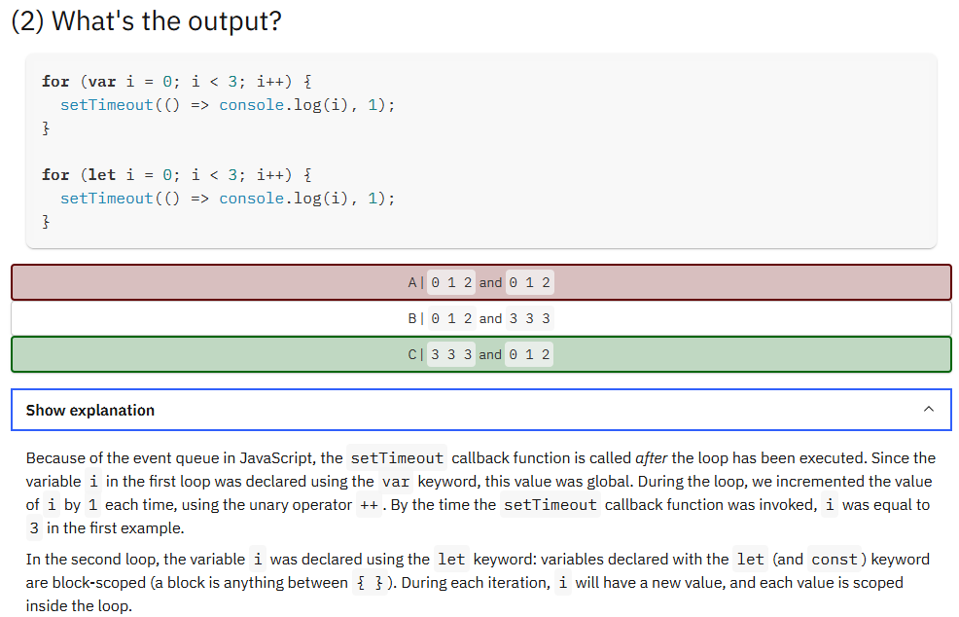 

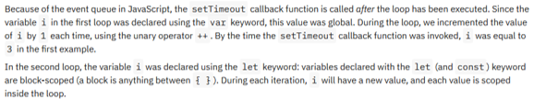

**Trust Issues with setTimeOut**

Consider below example, when code runs, GEC is created and push into the call stack. It runs 1st line, settimeout is stored into web APIs environment and timer is started for 5secs. And then end prints. Suppose there are million lines of code (here we have used **while loop to delay the code for 10secs**) and it executes, till that time settimeout code is not executed. Once the 5secs are over and timer is completed, the setTimeout function stores it in the callback queue which is executed only after call stack is empty, even if setTimeout is set to 0ms.

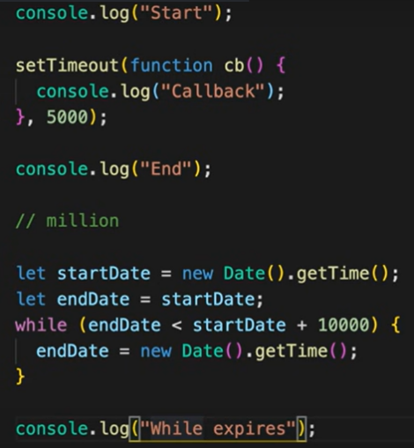 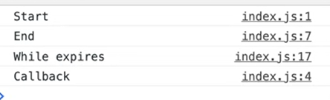

setTimeout ensures that minimum it will take the time mentioned because it may be paused due to call stack not empty.

**setInterval Method**

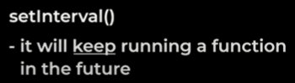

**Used to execute a function repeatedly at specified intervals.**

It also takes two values as setTimeOut method and is also an **asynchronous code.**

**This will keep running after every 2 seconds**

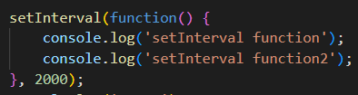

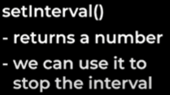

Helpful for clearInterval by setinterval id

**Callback Function**

A callback is a function that will be executed after another function gets executed.

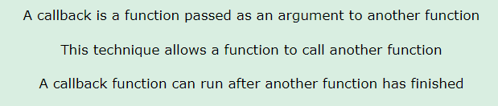

Functions that is passed as an argument to another function is called callback function.

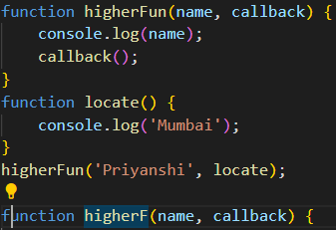 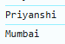

* In the below code, we are performing mathematical operations on the sum of two numbers. The operationOnSum function takes 3 arguments, the first number, the second number, and the operation that is to be performed on their sum (callback).
* Both divideByHalf and multiplyBy2 functions are used as callback functions in the code above.
* These callback functions will be executed only after the function operationOnSum is executed.
* Therefore, a callback is a function that will be executed after another function gets executed.

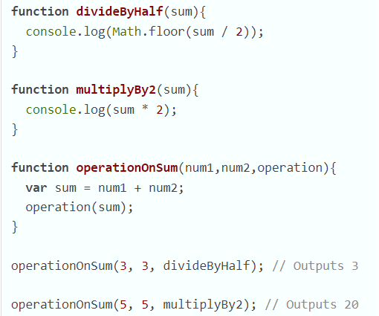

Callback are very powerful to handle async operations in JS. While writing callback we face 2 important issues.

**1. Callback Hell** (nested callback)

When a function is passed as an argument to another function, it becomes a callback function. This process continues and there are many callbacks inside another's Callback function. This grows the code horizontally instead of vertically. That mechanism is known as callback hell.

One call back inside another callback inside another callback or another APIs… it’s like a nested callback, this is known as callback hell.

This type of code structure is very unreadable and unmaintainable and also very tough to manage. Also known as Pyramid of doom.

**2. Inversion of control** (as we give control to another callback)

The callback function is passed to another callback, this way we lose the control of our code. We don't know what is happening behind the scene and the program becomes very difficult to maintain. That process is called inversion of control.

**Promises**

A **Promise** in JavaScript is an object that represents the **result (eventual completion or failure)** of an asynchronous operation.

**It handles asynchronous tasks in JS by providing a more readable and structured approach then callbacks for handling outputs.**

**Why are Promises important?**

Since we know callbacks come with two major issues:

1) Inversion of Control 2) Callback Hell

To resolve these issues, promises are very helpful. We do not pass our function inside another function, which means we are not giving control of our function to another function. Instead, we attach our callback function to the promise object, and whenever this promise gets resolved, our callback function executes automatically, helping to resolve the issue of Inversion of Control.

Since callback hell can be resolved by promise chaining, it eventually makes our code more readable and understandable, avoiding the pyramid of doom.

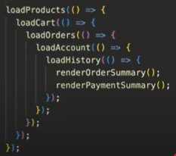 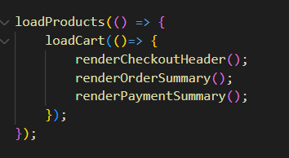

**Note: Use promises instead of callbacks**

Callback function Promise

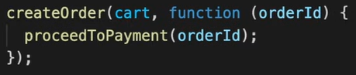 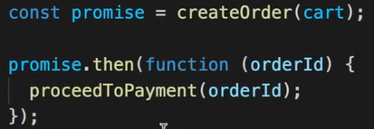

What is difference between two codes? callback and promise?

In callback, we are passing a callback function to another function. Here we don’t have control of our code.

In Promise, we are attaching a callback function to promise object. Promises gives us guarantee that or code will run when there is data present inside promise object.

A **Promise** has three states:

**Pending** → the operation is still in progress.  
**Fulfilled** (resolved) → the operation completed successfully. **Resolve()** - let us control when to go to the next step  
**Rejected** → the operation failed.

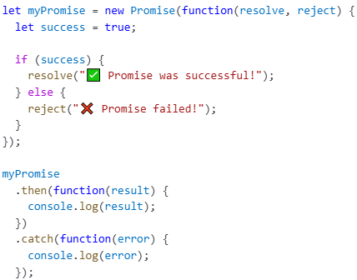 

We have created a new Promise. And it takes a function with two parameters: resolve and reject

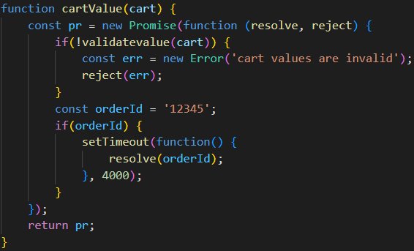

A Promise in JavaScript can be created using the new Promise() constructor.  
This constructor accepts a **callback function** with two arguments: **resolve and reject.**

* resolve(value) is called when the asynchronous operation completes successfully.
* reject(error) is called when the operation fails or encounters an error.

These functions are provided by JavaScript itself, and within a Promise, you can only either resolve or reject—nothing else.

If needed, an error object can also be created using **new Error('error message')** and passed to reject() for better error handling.

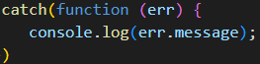

**Handling Promise Results and Errors**

.then() is used to handle a resolved value.

.catch() is used to handle any errors that occur **in the previous .then() blocks only**.

**Important**:

.catch() will **not handle errors in .then() blocks that come after it** in the chain.

Any .then() that appears **after a .catch()** will **still execute**, regardless of whether an error was caught earlier.

This behavior can be useful if you want to catch errors only for a specific section of the chain and continue execution afterward.

You can also have **multiple .**catch() **blocks** to handle different types or parts of errors, followed by a general .catch() at the end as a fallback.

**Returning Values in a Promise Chain**

Always remember to return a value in the .then() chain:

* If a .then() callback returns a value, it will be passed as an argument to the next .then().
* If it returns a Promise, the next .then() will wait for that promise to resolve or reject, effectively chaining the asynchronous flow.

Examples:

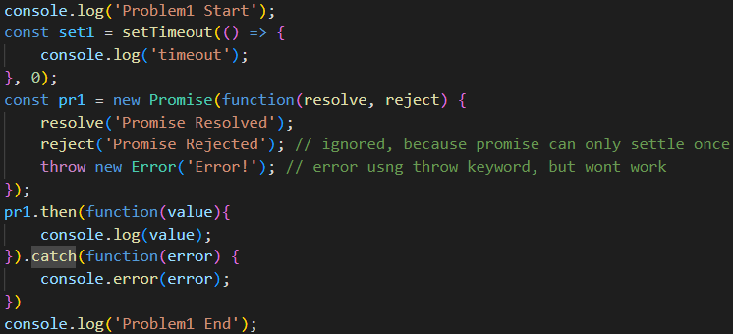

Once a promise is resolved or rejected, further resolve() or reject() calls are ignored.

And this approach is wrong because resolve was already called and reject is never executed.

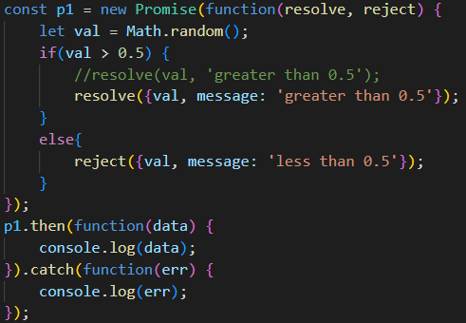

resolve() and reject() accept **only one argument.** Only val is passed—'greater than 0.5' is ignored.

If you want to pass both values, you need to **wrap them** in an object or array:



**Promise APIs**

**1. Promise.all()**

To run multiple promises at the same time and waits for all of them to finish.

Promise.all handles multiple promises together (simultaneously), returning an array of results when all promises are fulfilled, and throwing an error if any promise fails.

It takes array of promise as an input and make parallel API calls. Suppose there are 3 promises. When we write promise.all and give p1, p2, p3 it will make 3 parallel API calls and get the result.

If all the **API calls are success**, output of promise.all will be an array with the result of all these 3 promises. Overall time will be 3 seconds because promise.all will make all 3 API calls in parallel but it will wait for all of them to finish.

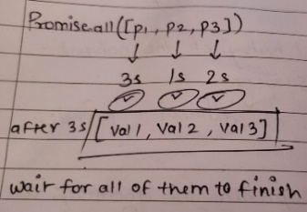

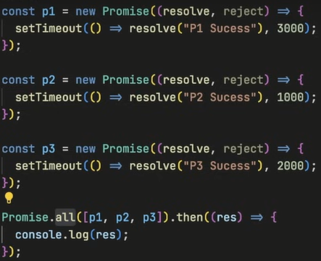 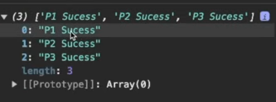

What if any of **promise API fails?** Consider p2 fails after 1 second, as soon as any of API calls get rejected, promise.all will throw an error. It will not even wait for other promises to be success or rejected.

What about p1 and p3? It may get success or rejected but it doesn’t matter.

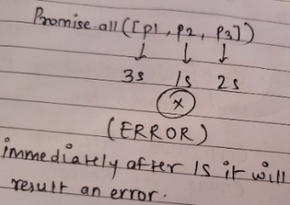

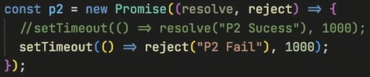 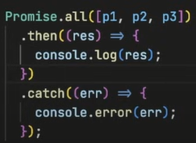 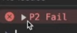

If p3 fails, will wait for 2 seconds and print the error but it will not print the p2 result.

**This is how promise.all works. If all the results are success, it will give the collective result. If any one of fails, whole chain fails.**

Use case: You can consider a scenario where you want all the result of promises or just quickly print an error.

**2.** **Promise.allSettled()**

Waits for all promises, even if some fail.

Promise.allSettled waits for all promises to settle (whether fulfilled or rejected) before returning an array of results or errors, making it suitable for scenarios where partial failures are acceptable.

If api calls are success, this will result the output. But if any of API fails, it will still wait for other promises to be settled.

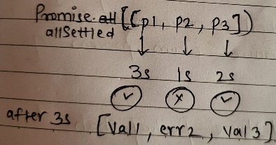

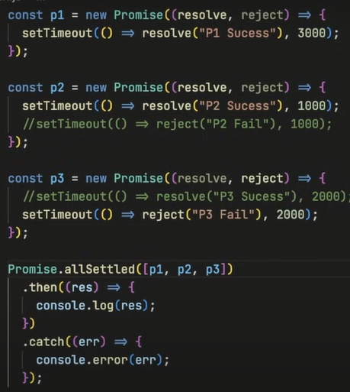  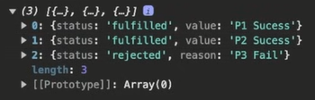

Promise.allSettled() never rejects, so .catch() is not needed. It always resolves with an **array of objects** like: console o/p

Summary: In promise.allSettled, it is exactly similar to promise.all in success case. But in failure case, even if one api fails, it will still wait for all the api calls to finish and then we will get the final status and value of error.

**3. Promise.race()**

Resolves or rejects as soon as the first promise is done.

Promise.race returns the result of the first settled promise, Settle promise can be success or failure. If it is success, it will return the success, if it is error, it will return the error. It is kind of a race.

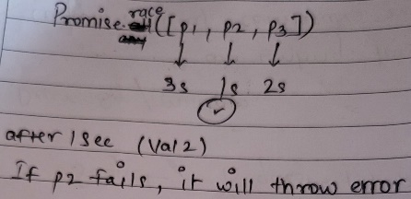

It will not wait for other promises to get settled.

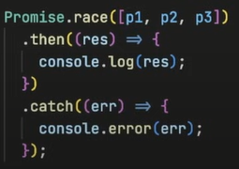 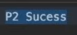

Whatever will be the result, will print it.

**4. Promise.any()**

It will **return the first settled resolved**/first settled success. If the first settled promise fails, it will wait for the second. If second fails, it will wait for third. It will keep on waiting till it gets the success. It’s a **success seeking API**. Seeking for first success. Once it gets the first success, it will return the result. If all of them fails, it will give you an **aggregate error**.

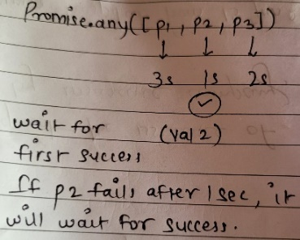

If p2 gets rejected/fails after 1 second, nothing will print. Promise.any will wait for first success and if p3 also gets rejected, nothing will print and after 3 seconds if p1 gets succeed, will print value1.

What if all the promises fails? Then the return result will be an aggregated error (array of all the 3 errors).

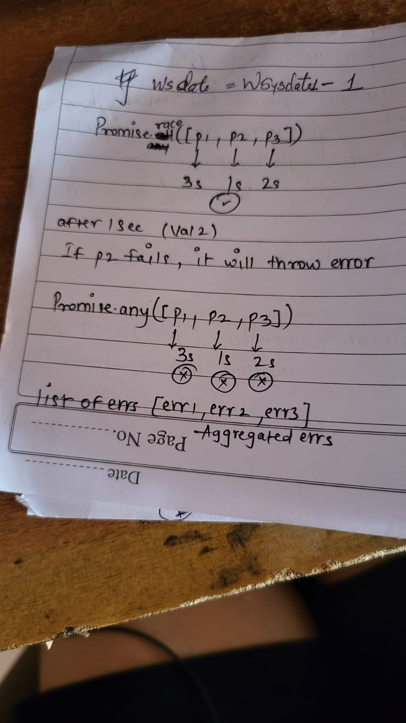

It is kind of a race but whenever it is successful then only it will return the result.

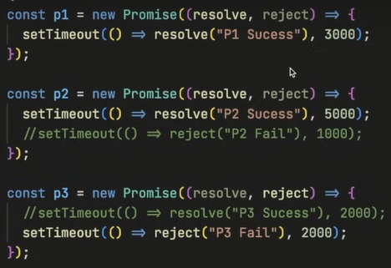 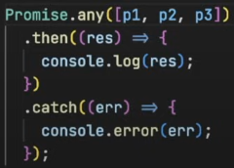 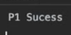

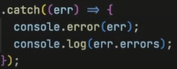 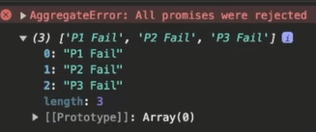

**Disadv of promises?**

Creates extra code. We need to create new promises, add resolve and to use .then

**Summary**

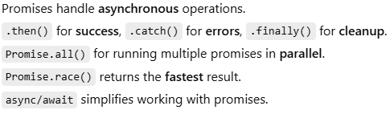

**Promise**: handles asynchronous operations using .then() and .catch().

**Async/await**: makes code easier to read and handle errors using try/catch.

**Async Await**

Even better way to handle asynchronous code. (Shortcut for promises)

**async** is a keyword that is used before a function to create async function. Async function always return a Promise.

If it doesn’t return a promise value but if it returns a normal value like string, number, console or anything which is not a promise, async function will take the value wrap it inside a promise and it will return it as promise value.

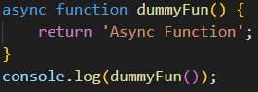 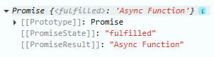

How to get value out of this promise? (.then method) (both ways to return a value)

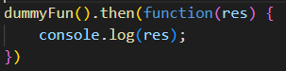

 

If the value is promise

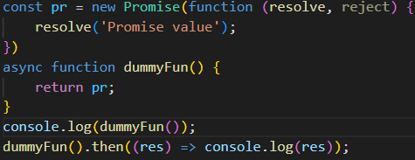 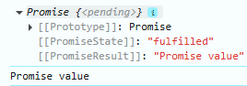

async and await together are used to handle promises’ and async and await make promises easier to write. It does not work with callback.

The await keyword can only be used inside an async function.

**await** makes a function wait for a Promise. (It pauses the execution of the code until the promise it’s waiting for is resolved, then returns the resolved value)

The keyword async before a function makes the function return a promise:

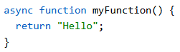 Same as -> 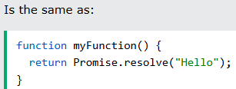

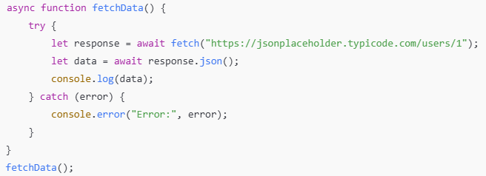

The await keyword makes the function pause the execution and wait for a resolved promise before it continues.

(let us wait for a promise to finish, before going to the next line.)

let value = await promise;

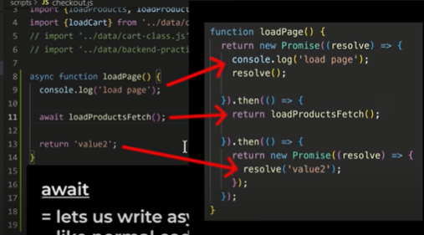

The closest function has to be async.

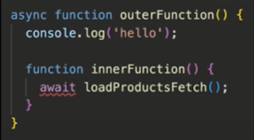

**Difference between promise and async/await?**

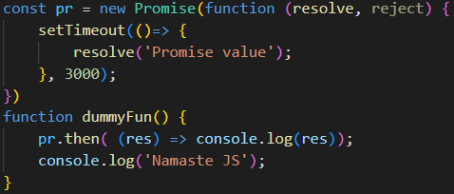 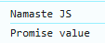

Here, we thought JS will wait for 3 secs for promise to be resolved and then will execute ‘Namaste JS’. JS engine will not wait for promise to be resolved.

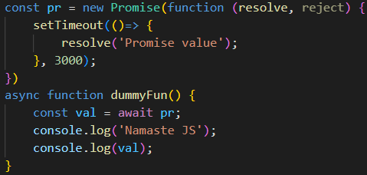 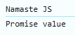

Here, it will wait for 3 secs and then console value gets print and after promise. JS engine was waiting for promise to be resolved.

**Example2**: if there are 2 promises and promise1 time is greater than promise2.

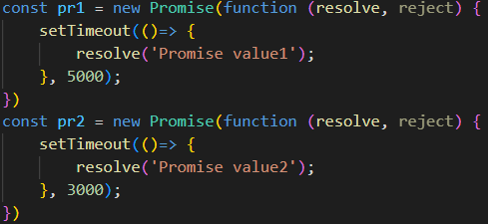 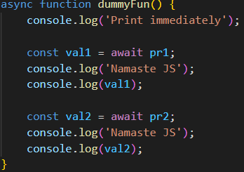 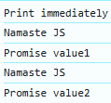

We think it will wait for 5 seconds and then 3 seconds NO.

Key Concept: A Promise Starts Execution as Soon as It’s Created! In JavaScript, when you create a Promise using new Promise(), the executor function (the function inside new Promise) runs immediately, even if you don't await it.

Right after this code runs, both pr1 and pr2 start their timers immediately! This is because the new Promise() constructor executes immediately, not when await is encountered.

What Happens in Execution?

**Step 1:** Function Execution Starts "Print immediately" is printed. The code encounters await pr1. Since pr1 is unresolved, dummyFun() is paused and removed from the Call Stack.

While dummyFun() is paused, pr1 and pr2 are still counting down in the background.

pr1 is set to resolve in 5 seconds. pr2 is set to resolve in 3 seconds.

**Step 2:** pr2 Resolves (After 3 Seconds) Even though dummyFun() is paused at await pr1, pr2's timer (3 seconds) still completes. pr2 is now resolved, but since no one is waiting for it yet, its resolved value is simply stored.

**Step 3:** pr1 Resolves (After 5 Seconds) pr1 finishes after 5 seconds, and dummyFun() resumes. "Namaste JS" is printed. The resolved value of pr1 ("Promise value1") is printed.

Now, execution moves to: const val2 = await pr2; But pr2 is already resolved (since it resolved at 3 seconds). So await pr2 does not wait again! The resolved value is returned immediately. "Namaste JS" is printed. The resolved value of pr2 ("Promise value2") is printed.

**Why did pr2 resolve before being awaited?**

Creating a Promise starts its execution immediately. pr2 does not wait for pr1 to resolve. Even if the function is paused at await pr1, pr2 keeps running in the background. By the time await pr2 is reached, pr2 is already resolved, so execution continues immediately.

**Example3**: if there are 2 promises and promise1 time is 3 seconds promise2 time is 5 seconds.

Step 1: print immediately will be printed

Step2: will wait for 3 seconds and print pr1 and wait for 2 seconds and print pr2.

**Error Handling**

When we’re sending HTTP requests, we could get unexpected errors.

1. Error handling in callback

If we get an error during request, we can handle it using below function

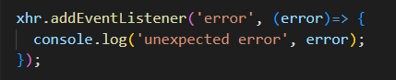

1. Handle error in promises

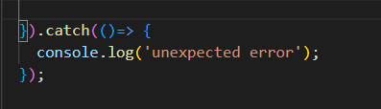

1. Error handling in async await

Using try catch block

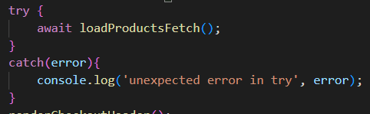

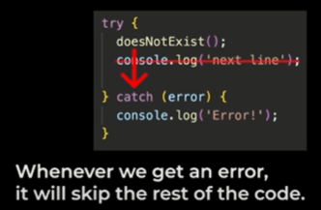

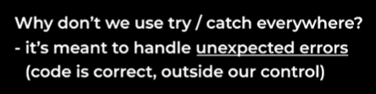

Our code is correct but something outside our control cause the error. So we can give some instructions on what to do

**Create an error**

We can manually create an error **using throw**

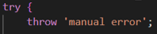

If were using promises, there are 2 ways to create an error.

* Throw – synchronous
* Reject – asynchronous, is a function. It lets us create an error in the future

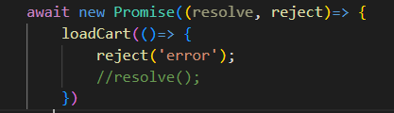

**this keyword**

**‘this’ keyword in global space**

‘this’ keyword in global space/scope will always have the value of the globalObject (globalObject depends on javascript runtime env). In case of browsers, globalObject is window. In nodejs, value of globalObject is global

 

‘this’ keyword refer to globalObject. globalObject in browser is window. In nodejs, globalObject is different.

**‘this’ keyword inside function -** ‘this’ keyword behaves differently in strict mode or non-strict mode.

**‘this’ value in a function, depends on strict/non-strict mode and also how the function is called (invoke).**

a. (In strict mode, "this" is undefined, in non-strict mode, "this substitution" takes place and "this" points to globalObject)

b. If the value of this keyword is undefined or null it will get replaced by globalObject only on non-strict mode.

Interview Ques: What is the value of this keyword inside function?

The value of this keyword inside function is undefined. But JS has something known as ‘this substitution’, so the value becomes equal to globalObject if we will not use strict mode.

**Non-strict mode**

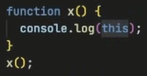 

Global space, function – In non-strict mode (this substitution will happen)

**Strict mode**

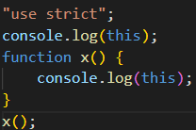 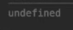

If the function is called without any reference, then the value is undefined.

 // undefined

If we invoke a function using globalObject (window) in strict mode, then ‘this will point to that globalObject.

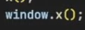 // window

**"this" in a method always points to the object that is used to invoke the method.**

If you make a function as a part of an object is known as method.

When you are inside an object and you create a function inside an object, this function x is known as method. So x is a method of obj.

If I call a function as obj.x(), the value becomes this obj (see the output).

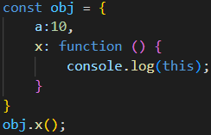 

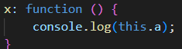 

**this** will reference to **obj** and **a** will refer to **a** property. (In simple words, this.a = obj.a)

call, apply and bind are used to share methods with another object (hence the "this" keyword reference would also change accordingly).

Example: I have object student1 and student2. Student1 has method and I want to reuse with student2.

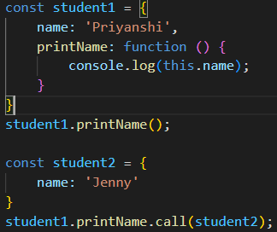  

The value of ‘this’ can be modified using call, apply and bind

**‘this’ keyword inside arrow function refers to the enclosing lexical context**

Arrow functions do not have their own ‘this’. They take the value from their lexical environment where they are enclosed.

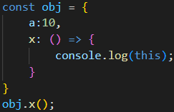 // window

‘this’ keyword will not behave like it is inside a function but it will behave like ‘this’ is present in a global space (as lexical context is global).

**‘this’ inside DOM element**

The value is reference to HTML element

 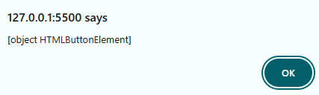

 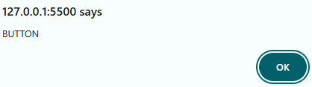

**call(), apply() and bind()**

In JavaScript, **call(), apply(), and bind()** are used to **control the this context** when calling a function.

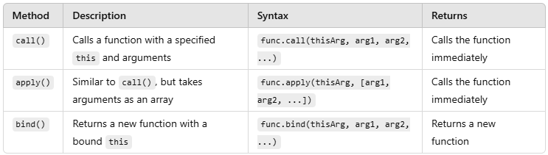

1. call()

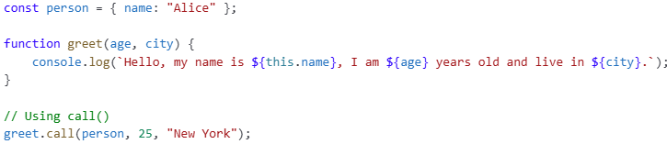



call() **calls the function immediately** with this = person.

call method is used to call the function with the given **this** value and argument can be passed individually.

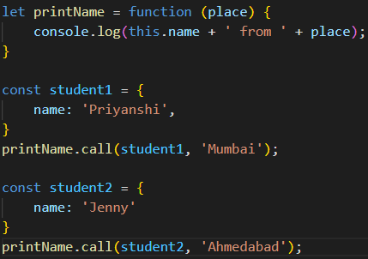  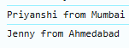

1. apply()





apply() works like call(), but **takes arguments as an array.**

apply method is similar to call method, the only difference is that instead of passing argument individually, will pass the argument in a list/array.

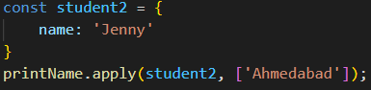 

1. bind()

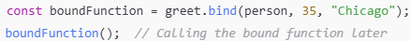



bind() **does not execute immediately—it returns a new function that can be called later.**

bind method is also used to override the this value but unlike call and apply it does not invoke the function instantly but returns a function with attached this and arguments which can be called later.

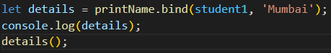 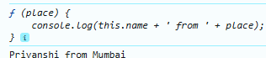

details will create of copy of printName and it will bind that with student1 object and will return a function. It doesn’t directly calls the method like call and apply and prints it rather than it will return a method that we can call later.

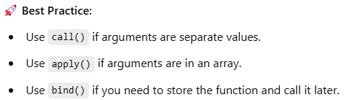

**Currying in JS**

Two ways to achieve function currying in JavaScript - through the use of bind functions and through closures.

Currying allows for creating multiple versions of a function by pre-setting some of its arguments.

1. Bind method

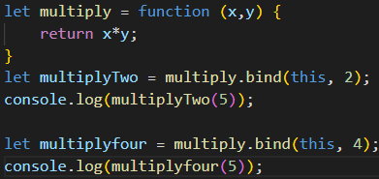 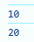

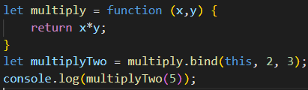 

Here, argument 5 will be ignored and 3 will be passed to y.

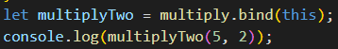 //10

We make a copy of multiply method and we create more methods out of it by pre-setting some arguments inside the function. Like how we pre-set the 2 as x in above example.

Function currying in JavaScript allows us to create copies of a function with predefined arguments. By passing an argument to the curried function, it behaves as if the argument was the first parameter. Currying can be done for any number of arguments. The bind method is used to create curried functions in JavaScript.

2. Closure

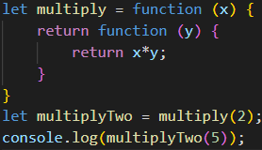 

Currying in JavaScript allows us to create new functions with pre-set arguments using either method chaining or function closures.

Method chaining involves creating new methods by pre-setting arguments inside the function.

Function closures involve returning a new function that has access to pre-set arguments even after it's returned. Currying allows for more flexibility and reusability in code.

Currying refers to the process of transforming a function with multiple arity into the same function with less arity. The curried effect is achieved by binding some of the arguments to the first function invoke, so that those values are fixed for the next invocation.

**Event Capturing** (trickling)

A propagation model where events are handled from the outermost element to the innermost.

**Event Bubbling**

A propagation model where events are handled from the innermost element to the outermost.

Bubbling & capturing are two ways of event propagation in the DOM tree

**Event propagation** is the way events travel through the DOM tree when an event is fired on an element. It consists of **three phases**:

1. Capturing Phase (Trickling Down) – The event starts at the top (document) and moves down to the target element.  
2. Target Phase – The event reaches the target element (where it was originally triggered).  
3. Bubbling Phase (Going Up) – The event moves up from the target element to the top of the DOM (document).

Consider below example:

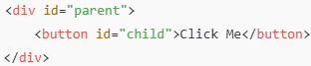

If you click the button (#child), the event follows these phases:

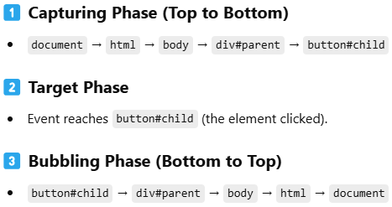

**Example of Event Bubbling (Default Behavior)**

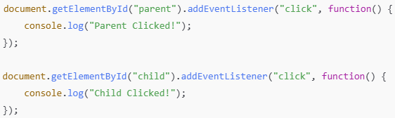

Expected Output (Clicking on **#child** Button)

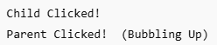

Bubbling **happens automatically unless stopped**.

**Example of Event Capturing (Top to Bottom)**

To use event capturing, pass true as the third argument in addEventListener().

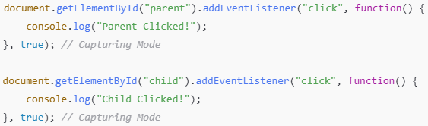

Expected Output (Clicking on #child Button)

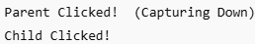

Capturing occurs only if explicitly enabled (true in addEventListener()).

**Stopping Event Propagation**

If you want to **prevent bubbling or capturing**, use **event.stopPropagation()**.

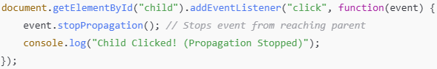

Now, clicking the child button will only log:

Child Clicked! (Propagation Stopped) // the **parent will not be triggered**.

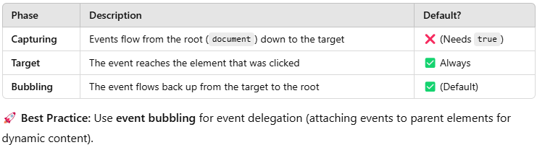

**Event Delegation** (efficient event handling in JS)

Event Delegation is a technique in JavaScript where you attach an event listener to a parent element instead of multiple child elements dynamically. This leverages the event bubbling mechanism, where events triggered on child elements bubble up to their parents. By handling events on a common ancestor, you avoid attaching separate listeners to every child element.

**Why useful for dynamically generated elements?**

Since the parent element is already in the DOM, it can listen for events on dynamically added children without needing new event listeners.

**What happens if the event bubbles up too far in the DOM?**

It might trigger unintended behavior if not properly handled. Using event.stopPropagation() can help limit bubbling when necessary.

**Can event delegation be used with focus and blur events?**

No, because focus and blur do not bubble. Instead, we can use the focusin and focusout events, which do bubble.

**How can you ensure that event delegation only applies to specific child elements?**  
Using [**event.target**](http://event.target/) to check if the event originated from the intended element before executing logic.

**Why Use Event Delegation?**  
**Improves performance** – Reduces the number of event listeners.  
**Handles dynamic elements** – Works for elements added later.  
**Keeps the DOM cleaner** – No need for multiple event listeners.

Instead of using the below event listeners,



Use event delegation

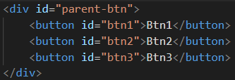

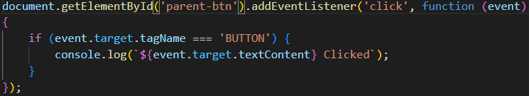

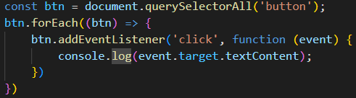

**event.target.tagName**

This will return the tag name of the element that was clicked (e.g., LI, DIV, A, etc.) in **uppercase**, even if the HTML tag is written in lowercase.

**Why**?

HTML tags are case-insensitive in HTML itself, meaning <li> and <LI> are both valid. However, when the browser processes these tags in JavaScript, it follows the **DOM specification**, which defines that tagName should always be in uppercase.

**Debouncing**

Debouncing is a technique to **limit how often a function is executed**. It’s commonly used when a function is triggered very frequently — like on: **keyup** (typing input), **scroll, resize, mousemove**.

**Why Do We Use Debounce?**

Imagine you're typing in a search box. You type **"apple"**, letter by letter.

We don’t want to call the API every time we press a key. Instead, we wait until user **pause** typing for a certain delay (e.g., 300ms), then make the call.

**Without debounce:**  
Every keystroke (a, p, p, l, e) triggers the search function = **5 API calls**

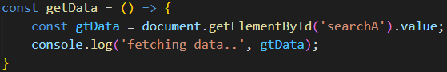 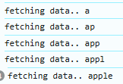

**With debounce:**  
It waits for you to stop typing for, say, **300ms**, and then only runs **1 API call**



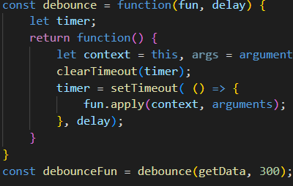 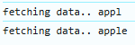

1. The debounce() function takes two parameters:

fun: The original function to execute.

delay: The wait time (in milliseconds).

2. Inside debounce, we create a **timer** variable to manage the delayed execution.

3. When the debounced function is triggered:

* It **clears any existing timer** using clearTimeout().
* Then it **sets a new timer** using setTimeout(), which schedules the original function to be executed **after the delay**.

4. If the event is triggered again before the delay finishes, the timer resets. This means the function will only execute **after the user stops triggering the event for the specified delay**.

5. We use fun.apply(context, args) to preserve the correct this and arguments when the function is finally executed.

Sumary: Debounce delays the execution of a function until a certain time has passed since the last time it was triggered — making it ideal for reducing function calls in high-frequency events like typing or scrolling.

**Throttling**

Throttling is used for **performance optimization** or **rate limiting the function call/execution**.

**Throttling** means **limiting how often a function runs**, even if it's called many times quickly.

It’s useful when something happens **many times in a short time** (like scrolling or resizing the window), and you want to **control** how often a function actually runs — to **improve performance**.

Example -

Let’s say you’re running a function every time a user scrolls the page.

**Without throttling:**

If the user scrolls 100 times in 1 second, your function runs **100 times** = ❌ **Bad for performance**!

**With throttling:**

You can tell it: "Run this function **only once every 500ms**."

So even if the user scrolls a lot, the function will run **only 1–2 times per second** = ✅ **Much better!**

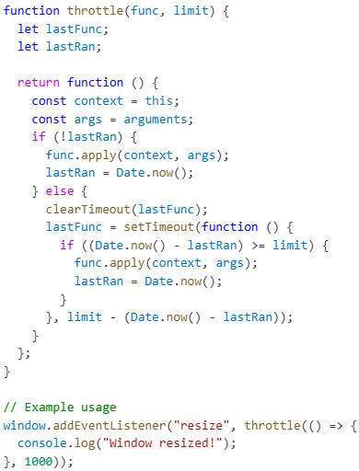 

Here `apply` method takes an array of arguments. This can be useful when you don't know how many arguments will be passed to the function.

**Where throttling used?**

Scrolling, resizing the window, mouse movements, button clicks, API calls

**Debouncing vs Throttling**

**Debounce**: Ensures a function is executed **only after a delay** (useful for search inputs).

**Throttle**: Ensures a function runs at most **once in a given time period** (useful for scroll events).

Debouncing and throttling both are **used for optimizing performance** of a web application. **How**? It happens by limiting the rate of function calls. Sometimes the functions are called repeatedly, unnecessarily. We can limit the rate of execution and optimize the performance.

**Example 1** - search input

Debouncing - If the difference between two key press events is greater than a certain limit let say 300ms, then only make API call and execute the result.

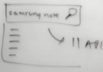 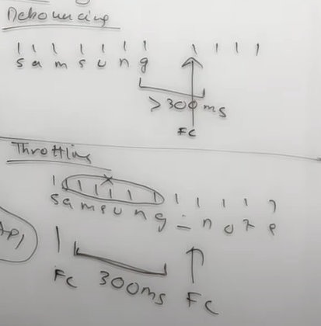

Throttling – If the difference between two function calls (last function call and this function call) is 300ms, then only make API call. It’s like calling an API call after a certain limit of time.

Example - Consider we have made a function call on **s** (refer example) and then wait for a certain period of time (300ms). Up to 300ms, it will ignore all other keywords (key events) and then only make a function call after 300ms.

Suppose you’re typing ‘samsung’ and suppose 300ms expired after ‘n’, so it will make a function call after ‘n’ and get you the results of ‘samsun’



**Example 2** - we want to track how many times a user resize a website.

We were making 1000s of API call.



Debouncing - it will make an API call if we take a pause, or resize it slowly if the certain delay is greater. It will make few API calls.

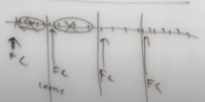

Throttling - even if we resize fast or slow, it will make an API call after every 100ms.

**Example 3** - You're playing a shooting game. You press and hold the **fire button** 🔘 to shoot bullets.

Debouncing — “Only fire if you stop pressing for a while”

Analogy: Your gun will only shoot once if you stop pressing the fire button for 500ms.

You keep tapping → nothing happens. You stop for a moment → 💥 one bullet fires.

Throttling — “Fire only once every fixed time, no matter how many times you press”

Analogy: Your gun can shoot once every 1 second, even if you're holding the fire button or tapping it like crazy.

You press 10 times → 💥...💥...💥 (one shot per second)

**Lazy Loading**

Lazy Loading is a technique where resources **(like images, scripts, or modules) are loaded only when needed**, instead of at the initial page load.

**Why** Use Lazy Loading?  
**Improves performance** – Loads only what is required.  
**Reduces initial load time** – Speeds up page rendering.  
**Optimizes bandwidth usage** – Saves unnecessary data loading.  
**Better user experience** – Users don’t wait for unused resources.

1. **Lazy Loading Images**

**Without Lazy Loading** (Loads All Images Immediately)



Issue: The browser loads all images at once, slowing down the page.

**With Lazy Loading** (loading="lazy")



Now, the image loads only when it appears in the viewport.

1. **Lazy Loading JavaScript Modules** (Dynamic Imports)

JavaScript dynamically loads modules when required using import().

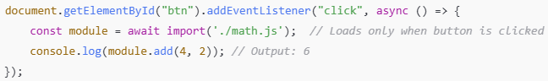

Instead of loading math.js on page load, it loads when the button is clicked!

1. **Lazy Loading Videos** (YouTube Example)

Instead of embedding a YouTube iframe directly (which slows the page), use a placeholder image and load the video on click.

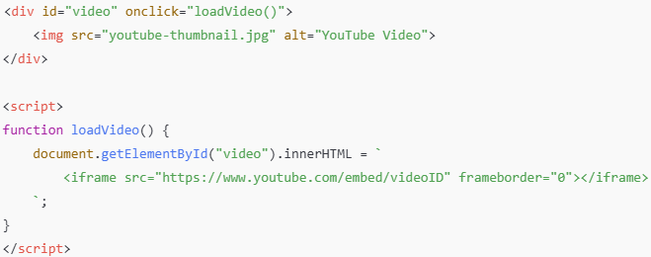

The iframe loads only when clicked, reducing unnecessary requests.

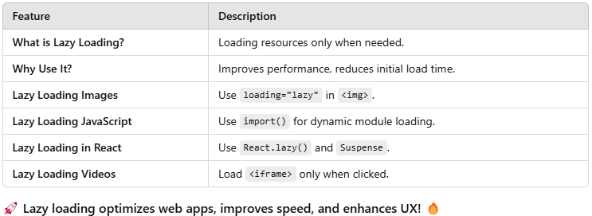

**defer vs async**

**async** and **defer** are Boolean attributes which are used along with script tags to load the external scripts efficiently into our web page.

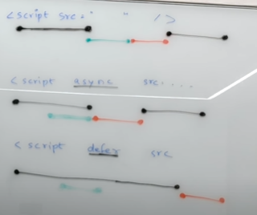

In normal scripts, HTML parsing goes on. As soon as the script tag is encountered. Scripts are fetched from the network. Then and there they are executed and after that HTML parsing continues.

**In async attribute**, HTML parsing goes on. The script are fetched in async manner and parallel. As soon as the script are available, they are executed after only HTML parsing continues.

**In defer**, HTML parsing goes on. Scripts are fetched in parallel and only executed once the HTML parsing is complete.

Async attribute does not guarantee the order of execution of the scripts, but defer does.

If you **must** place JavaScript in the <head>, you should use the **defer** or **async** attribute:

**defer**: Ensures the script loads in parallel with HTML but executes **after the document is fully parsed**. (Recommended)

**async**: Loads the script asynchronously and executes it **as soon as it’s ready** (may not maintain execution order).

**Prototype and Prototypal Inheritance**

Inheritance - when one object trying to access methods and properties of another object.

Prototype - Whenever you create a JS object, JS engine automatically without even letting you now attaches your object with some hidden properties and functions. And these hidden properties and methods can be accessed by just typing obj.location

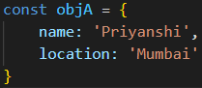 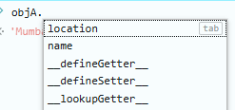

Not just with objects, suppose we create a function and we check it on console, functions get access to a lot of other things just like length, apply, bind an other functions. And functions are also objects.

Whenever you create anything in JS, even a variable, they get access to some of the hidden properties and methods. So these comes via prototype.

Whenever you create any object, JS engine put these hidden properties into an object and attaches to your object. It attaches an object to your original object and that is how you get access to those properties and methods. 